Protect and Connect: A Conservation Plan for Washington, NH

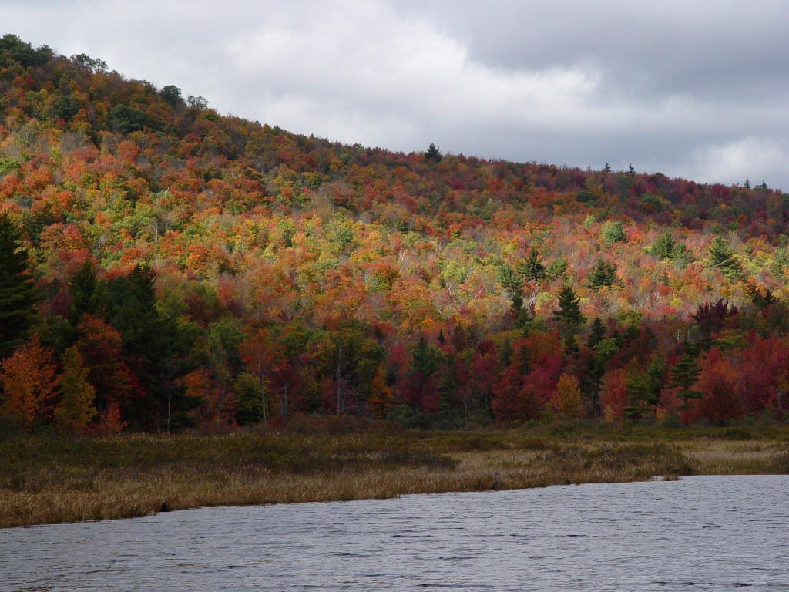

December 2008

Produced by Christopher Kane & Peter Ingraham

With assistance and funding from the Town of Washington Conservation Commission and Planning Board

Kane & Ingraham
Conservation Consultants
6 Donovan Street • Concord, NH 03301 • 603-848-7572 • www.kiconservation.com
Acknowledgements

The authors would like to acknowledge the assistance and advice of a number of people who helped in the improvement of this study. They include members of the Washington Planning Board, Washington Conservation Commission, and interested citizens of the Town. In particular, the following people were invaluable in their assistance.

Carol Andrews
Lionel Chute
Rich Cook
Don Richard
Sandy Robinson
Nan Schwartz
Jed Schwartz

Cover photo by Jed Schwartz

Table of Contents

Acknowledgements

Prelude 1
I. Introduction 3
II. Background 4
III. Conservation Goals 5
IV. Other Studies That Pertain to Conservation in Washington 6
V. Recommendations for Land Conservation 13
Conservation Priority Areas 13
Town-wide Land Conservation Priorities: 43
Land Protection Options 45
VI. Recommendations for Regulatory Actions 50
VII. Recommendations for Outreach and Education 53
VIII. Recommendations for Voluntary Actions 54
IX. Recommendations for Further Study 56
X. Appendix. Sources 58

List of Figures

Figure 1. Q2C Map for Washington with Conservation Priority Areas 7

Figure 2. Detail from “Highest Ranked Wildlife Habitat by Ecological Region” 9
map, NHF&G Wildlife Action Plan, 2007

Figure 3. Map of Conservation Priority Areas 13

List of Maps

Map 1. Conservation Priority Areas 39

Protect and Connect: A Conservation Plan for Washington, NH

Prelude

In 2005 the Town of Washington Planning Board in consultation and cooperation with the Town of Washington Conservation Commission identified the need for a Natural and Cultural Resource Inventory and Conservation Plan for the Town. Concerns about growth and the informed use of natural and cultural resources, both from the boards and from the public in general underscored the need for such a study. Funding was approved by the Washington Planning Board and the Washington Conservation Commission in February of 2006. The team of Chris Kane and Pete Ingraham was selected to carry out the project with assistance from the Conservation Commission. The Planning Board and other interested citizens also participated at various stages of the project.

The project consists of several parts, in most cases accompanied by maps:

Natural and Cultural Resource Inventory to identify and locate, primarily with the use of GIS data, the significant natural and cultural resources in Town;

- Constraints to Future Development Study built on these findings that identified areas with limitations on development;

- Build-out Analysis to provide a perspective on potential future growth;

- Co-Occurrence Analysis to identify areas of Town with multiple important resources;

- Threats Model study that identified the potential threat from development based on the relative potential or desirability for future development;

- Greenways Model to identify future connections between existing conservation lands;

Conservation Plan based on all previous studies, focusing attention on specific resources in specific areas of the town, and making recommendations for conservation.

The recent Town meeting votes in favor of initiatives put forward by the Planning Board show that most people in Town are concerned about the future of Washington and are looking to find ways to better protect their resources and quality of life. Many people express the wish to maintain Washington as a rural community and to protect the many outdoor recreation choices that people value. Once adopted by the Washington Planning Board this document will become part of the Washington Master Plan.

I. Introduction

Washington is blessed with abundant high-quality natural resources, as the recent Natural and Cultural Resource Inventory attests. The relatively un-fragmented and pristine condition of large portions of the Town makes many of these resources important on a state-wide level. Recreation is still widely available for people to enjoy these resources, as well as financial benefit from forestry and agriculture. As more people discover the qualities that make Washington such a desirable place, growth is inevitable. Planning for this growth and guiding it to areas where important natural resources will be less impacted is one of the goals of this plan.

Protection of these resources will take a variety of means. Many options are available to the Town as it strives to conserve these significant Town resources. These options include land protection both opportunistic and strategic, regulatory initiatives such as zoning or wetlands ordinances, outreach efforts to inform the citizens how they can get involved in conservation, and voluntary initiatives to conserve specific resources such as lake water quality. Using a combination of approaches and tools, the natural resources, wildlife habitat, recreational opportunities, traditional landscapes and the rural character of Washington can be preserved for future generations to use and enjoy.

II. Background

The findings of the concurrent Natural and Cultural Resource Inventory offer a new way to view the Town of Washington. While some findings were not unexpected, others were quite surprising. Here are some of the highlights:

- High quality, high-yield groundwater aquifers are very uncommon in Town;

- The entire Town was mapped as being significant on a state-wide or state-regional basis by the 2005 NH Fish and Game Wildlife Action Plan, an exceptional finding;

- Numerous undeveloped ponds and associated tributaries still exist in most parts of Town;

- Much of the town is protected, but conservation areas south of Pillsbury State Park are unconnected;

- Several flood prone areas already have residences and other structures within the floodway areas;

- Washington and East Washington villages remain largely intact, with important civic, religious and residential structures preserved in their original style;

- None of the 316 acres of actively used, productive farmland in Town is protected from conversion to development;

- Approximately half of the 2200 or so lots in Town are currently un-built;

- The most pristine portion of the entire Ashuelot River flows through Washington;

- Prime Agricultural Soils and Soils of State-wide Significance are very uncommon in Town.

- There are 57 miles of established snowmobile trails and 60 mile of hiking/skiing trails in Town;

III. Conservation Goals

The Natural and Cultural Resource Inventory identified and highlighted areas in Washington where natural and cultural resources exist. This first logical step was necessary in order to inform decisions that the Town may make toward the protection, management and considerate use of these resources. In order to help guide Town decisions regarding conservation in the future, to guide the implementation of this plan, to set priorities the Washington Conservation Commission has articulated the following set of Conservation Goals.

1. To promote the conservation, protection and responsible management of the natural resources of the Town

2. To protect and enhance the ecological integrity of the Town's diverse natural communities and wildlife habitats

3. To protect the Town’s water quality, wetlands and aquifers

4. To protect the natural ability of the landscape to withstand flooding, thus reducing the risk to residential and recreational areas

5. To protect and help sustain small farms in the present and in the future

6. To protect the productive capacity of forest land for its current and future benefits

7. To maintain recreational opportunities through protection and connection

8. To protect the Town's historic sites and rural landscapes

9. To sustain the quality of life and rural character of the Town

IV. Other Studies That Pertain to Conservation in Washington

The prime source on which this Conservation Plan is based is the recent Natural and Cultural Resource Inventory. Numerous other plans and studies that pertain to the Town of Washington’s natural and cultural resources were also reviewed, and contributed to this report. Several other major studies, including the New Hampshire Wildlife Action Plan, A Land Conservation Plan for the Ashuelot River Watershed, the Ashuelot River Corridor Management Plan, the Quabbin to Cardigan Initiative arrived at similar conclusions: the Town of Washington has remarkable natural resources which are considered a high priority for protection. A complete list of these sources can be found in the Appendix. The following summaries from several sources underscore and enhance the findings of the Natural and Cultural Resource Inventory, and offer alternative perspectives on the resources of the Town.

Ashuelot River Corridor Management Plan

This Plan, produced by the Ashuelot River Local Advisory Committee, has specific recommendations for the headwaters section of the river that starts in Washington at Butterfield Pond. This section is the only section designated by the Committee as being in a predominantly “natural” condition, the most pristine category measured. According to this plan protection of the intact-forested riparian buffer will help prevent sedimentation, nutrient enrichment and overheating during warm summer months. Prevention of soil erosion during commercial activities can be minimized by adherence to Best Management Practices. Monitoring of septic systems, especially on the shores of Ashuelot Pond is important given the density of structures and presence of over-used systems. Because of the sensitivity of rare species and natural communities in the Ashuelot corridor, the plan strongly urged adoption of a land conservation strategy, to preserve not only ecological resources but also recreational and tourism opportunities. In order to preserve the cultural and historic features such as old dam and mill sites, the plan recommends that the resources be more fully documented and, if appropriate, registered with a State or Federal historic preservation agency.

Management Plan for the Town of Washington Forest Lands

This very thorough plan was commissioned by the Town of Washington and produced by Lionel Chute and Garrett Dubois in 1999. Most of the findings and recommendations relate specifically to forestry, although plant species, soils and other biological features are also addressed. There were also recommendations for new trails in some locations. The authors found a critical need for property surveys for most of the Town Forest properties. These properties are designated as “official Town Forests” according to RSA 31:110. This designation does not however prevent future conversion to non-conservation uses; therefore they are treated as “public lands” as opposed to permanently protected conservation lands in this plan. The following findings are highlighted:

- Farnsworth Hill Town Forest – needs survey
- New Road Town Forest – consider new trail
- Barrett Pond Town Forest – needs survey
- Back Mountain Town Forest – needs survey
- Huntley Mountain Road Town Forest – Consider new trail to summit
- Camp Morgan Town Forest – extend hiking trail further south

A Land Conservation Plan for the Ashuelot River Watershed

The Town of Washington figures prominently in this comprehensive, state-of-the-art 2004 study that is the result of a partnership between the NH chapter of The Nature Conservancy, the Society for the Protection of New Hampshire Forests, The Monadnock Conservancy, and the Southwest Region Planning Commission. The plan first identified conservation targets (significant resources), then proceeded to identify stresses to these targets as well as sources of stress, and finally developed strategies for conservation activities. The study identified the following set of threats to the persistence and health of the conservation targets: habitat destruction, habitat fragmentation, altered forest structure, altered hydrologic regime, toxins and other contaminants, altered species composition, nutrient loading, sedimentation and thermal alteration among others. Primary causes or sources of these threats include incompatible residential development, development and upgrade of roads and utilities, poor logging practices, presence and operation of dams, invasive species and forest pests, inadequate storm water management, atmospheric deposition (mercury, etc.) and incompatible recreation (ATV’s etc.).

Thirteen areas in the watershed were identified as being of particular importance for plants, animals and ecosystems. One of these areas, the Ashuelot Headwaters area, is located partially part in Washington. This stretch is the only one that is designated “natural” by the NH Rivers Management and Protection Program. The plan identified the following conservation targets, or significant resources, in this area: Major Tributary (Ashuelot Mainstem), Un-fragmented Forest Ecosystems (dominant forest types of spruce-fir and northern hardwoods), Important Wetland Communities and Complexes (numerous), and Significant Wildlife Habitat (extensive riparian zone and interior forest).

The plan found valuable connectivity opportunities between the Andorra Forest easement to the south, and Pillsbury State Park to the north. The area, which is a total of 5,940 acres in the Towns of Washington, Lempster, and Marlow, contains only 100 acres of legally restricted open space lands, and 831 acres of Town forests.

Quabbin to Cardigan Conservation Collaborative

The broad forested highlands stretching 100 miles from the Quabbin Reservoir Reserve in central Massachusetts to Mt. Cardigan in the southern White Mountains have recently been recognized for their regional importance as one of the largest remaining intact contiguous forests in Central New England. Washington lies in the very heart of this area, which is the subject of a public/private initiative to protect a corridor of interconnected conservation lands along the Monadnock Highlands.

This area forms the division between the watersheds for the Connecticut River and the Merrimack River, making its streams and rivers important source water for both watersheds. According to the Collaborative report, recent trends in the region indicate an increased rate of conversion from forest to development as long-time timberland owners sell off their holdings. At the same time, land prices are increasing, tipping the balance economically toward the conversion and subdivision of working forest lands which have until recently not been considered at risk for development.

Figure 1. Q2C Map for Washington with Conservation Priority Areas

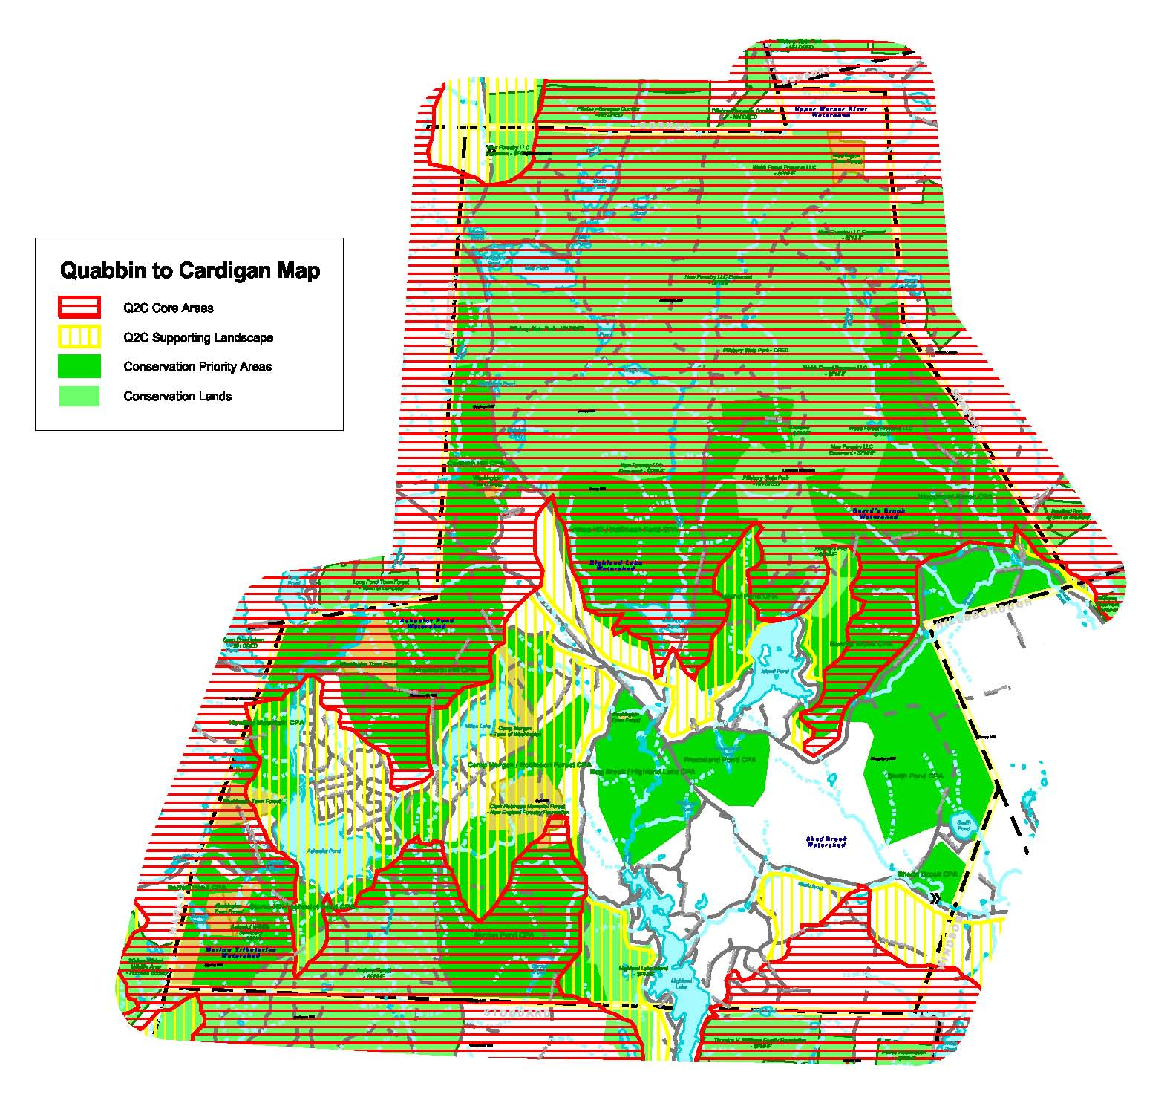

A consortium of 23 private organizations and public agencies has come together to study this area and to develop strategies for its protection. They identified a 3,100 square mile focus area, and developed a list of goals. These goals are to complete region-wide natural resource mapping; identify and refine focus areas for targeted, proactive land conservation; accelerate proactive land protection in the focus area; identify and secure private funding sources; identify and secure additional federal, state and local conservation funding; and promote the initiative regional vision with key stakeholders and the public.

Several important and significant parcels have already been protected as a result of the Quabbin to Cardigan, or “Q2C” Collaborative, and the project is ongoing. Projects in the immediate Washington area have already been identified as Q2C targets for protection. This major land protection effort holds promise for Washington and the surrounding Towns as it works to protect the most significant remaining forested highlands in the region.

The Q2C has identified areas for proactive conservation, as well as supporting landscape areas. The majority of the land area of the town of Washington is mapped for Core Areas for conservation, with other areas of Supporting Landscape also included. As the following Figure 1 indicates, there is remarkable concurrence between the Q2C mapping and most of the Conservation Priority Areas in town shown in Figure 3.

Wildlife Action Plan, NH Fish & Game Department

In the most comprehensive and sophisticated study yet undertaken in New Hampshire for wildlife habitat mapping and conservation planning, the New Hampshire Fish & Game Department unveiled its Wildlife Acton Plan (WAP) in late 2006. Recently updated, and subject to continuous refinement, it is an important tool for Towns and organizations to use in planning the conservation of high quality and/or imperiled wildlife habitat, rare plant habitat and exemplary natural communities and systems. The plan analyzed information about habitat condition at both statewide and regional levels, and mapped areas of the state that ranked the highest. The goal was to provide regional planners and conservation professionals a tool for identifying the most critical wildlife habitat locations in their area. A noteworthy finding for the purposes of this report is that the entire town of Washington was mapped by the Plan as being extremely significant for wildlife habitat, much more significant than most other Towns in NH. Every portion of the Town was ranked as important in some category.

WAP Highest Ranked Wildlife Habitat by Ecological Region Map

Figure 2 below is an excerpted detail of Washington from a map produced for the New Hampshire Wildlife Action Plan in 2007. In the Figure, areas in purple indicate Tier 1 Habitat: Highest Rank Habitat by Condition in New Hampshire. Green areas indicate Tier 2 Habitat: Highest Rank Habitat by Condition in Biological Region. Salmon-colored areas indicate Tier 3 Habitat: Supporting Landscapes that include top-ranking condition streams and lakes, large forest blocks or statewide significance, or specific animal, plant and natural community occurrences identified as critically imperiled. Beige indicates Wildlife Habitat not top-ranked. Violet water bodies indicate Highest Rank Habitat by Condition in New Hampshire.

As the map detail indicates, a very significant proportion of the Town is classified as Highest Rank either on a State or Ecological Region basis, primarily due to the high-condition tributaries in the upper portions of the Ashuelot River watershed; the remainder of the Town is classified as Supporting Landscape. Of special note are the Tier 1 or Highest State ranking of all major lakes and ponds in the Town.

Figure 2. Detail from map “Highest Ranked Wildlife Habitat by Ecological Region”, NHF&G Wildlife Action Plan.

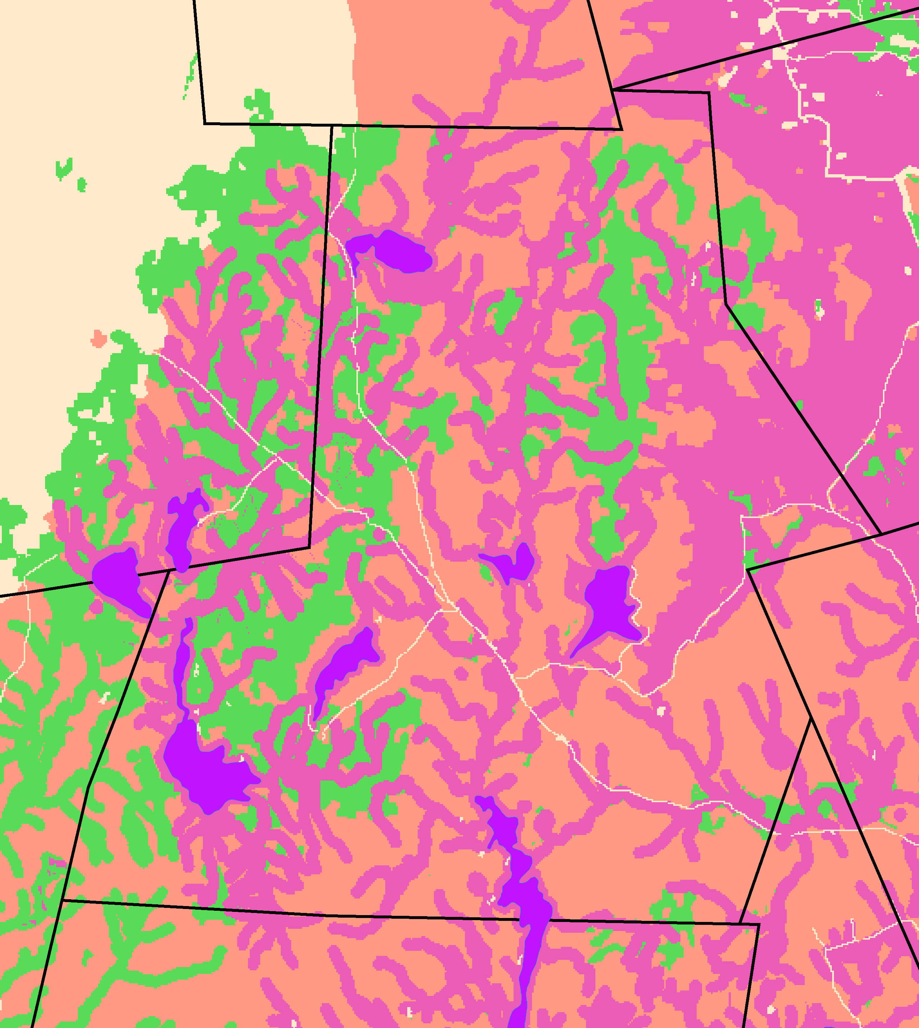

Map Detail Key:

Purple: Tier 1: Highest Rank Habitat by Condition in NH
Green: Tier 2: Highest Rank Habitat by Condition in Biological Region
Violet: Highest Rank Water Bodies Habitat by Condition in NH
Salmon: Supporting Landscapes
Beige: Wildlife Habitat not top-ranked

Washington

Washington is in the Sunapee Uplands Eco-regional Subsection as delineated by The Nature Conservancy for the purposes of ranking terrestrial habitats. Washington is in the Southern Uplands Watershed Group for purposes of ranking wetlands and floodplain forests.

New Hampshire’s Vanishing Forests

This 2001 report of the NH Forest Land Base Study on the state of New Hampshire’s forests was produced by the Society for the Protection of New Hampshire Forests to document the effect that growth is having on the forests and other natural resources of the state. Here are some of the major findings:

- New Hampshire loses about 13,000 acres of forest annually to land conversion.

- Forest conversion is driven by population growth and the rising rate of land consumption per person.

- State-wide about 10% of the harvested area is being terminally harvested each year in preparation for development.

- Forest fragmentation is most advanced where population and recreational development are greatest.

- Declining parcel size impairs the profitability of forest management.

- Owners of larger parcels experience significant economies of scale when they harvest.

- Owners of larger parcels are more likely to employ foresters and have written management plans.

- Approximately one quarter of the (state-wide) forest land base is permanently protected, but productive soil areas are proportionately less protected.

- Recommendations that relate to forest lands in Washington include developing a Town master plan for forestry; pursuing public acquisition programs to protect productive land for forestry; designating forest conservation zoning districts; requiring cluster development zoning to conserve strategic forestland.

V. Recommendations for Land Conservation

Introduction

Washington is certainly blessed with exemplary natural places and resources, including abundant surface water resources, productive forests and important farmland, high-value wildlife habitat, and extensive recreational access. Washington is fortunate to still have the opportunity to protect its most important resources; most of the wild places remain intact. The Town of Washington should make it a priority to engage the resources of the Town as well as an involved citizenry to permanently protect these beautiful places.

The conservation goals set forth in Chapter III above will require that a variety of approaches be used to fulfill them. In the case of land conservation, resources are protected comprehensively at the parcel scale. Practicality dictates that protection of these lands be accomplished both strategically and opportunistically (e.g. when individual owners take the initiative) with the vision that, over time, corridors of linked conservation areas will be created.

Land conservation is a means of legally restricting some uses on the land, while specifically allowing other uses. Allowed uses generally include traditional uses of open space including forestry, agriculture and recreation. Restricted uses generally include residential, institutional or commercial development and construction, mining and removal of soil and minerals, and subdivision, among others. The particular method and terms are tailored to the parcel and project depending on what resources are being protected, and the wishes of the parties involved. It’s important to note that land conservation is a voluntary process of agreements between willing parties, and does not involve the forced taking of land or real interest. For a more complete treatment of this topic see Land Conservation Options in Chapter V below.

Conservation Priority Areas

Rationale and Basis for Selection of Priority Conservation / Recreation Areas

In an attempt to help fulfill the Conservation Goals above, and informed by Natural Resource Inventory and by previous plans and studies, five Conservation Focus Areas were selected as priority areas for land conservation. Within these five areas a total of 15 specific primarily un-developed areas were identified as Conservation Priority Areas. These areas were selected as priorities because, based on the referenced studies, they contain the most significant natural resources in Washington that remain un-protected. The resources they contain are among the most significant in the Town, by virtue of being high-quality, uncommon, at risk, critically important, or in pristine condition. Taken together they encompass much of what still makes Washington special and unique – rural landscapes, productive forest and farm lands, wetlands and ponds, scenic vistas, pristine watersheds, trails and trout streams. See Figure 3 below, a map of the Conservation Priority Areas.

These Conservation Priority Areas were selected on the basis of mapping and local input, but have not been verified on the ground per se. Actual field surveys would improve the accuracy and basis for the delineation of the boundaries of these areas. Also, additional important resources that were not captured by the GIS data are likely to exist elsewhere in the Town, outside these Conservation Priority Areas. Therefore, additional priority areas may be identified at a later time based on information yet to be gathered. The boundaries of these areas are proposed for planning purposes, and have no regulatory limitations on land use within these areas. Please see Conservation Priority Areas Map for specific areas.

Figure 3. Map of Conservation Priority Areas
Conservation Priority Areas (in dark green)

1. Starks Hill / Ashuelot Pond CPA 9. Woodward Brook CPA
2. Barrett Pond CPA 10. Shedd Brook CPA
3. Farnsworth Hill CPA 11. Smith Pond CPA
4. Huntley Mountain CPA 12. Barden Pond CPA
5. Codman Hill CPA 13. Camp Morgan/Robinson Forest
6. Island Pond CPA 14. Bog Brook / Highland Lake CPA
7. Ames Hill / Halfmoon Pond CPA 15. Freezeland Pond CPA
8. Beards Brook CPA
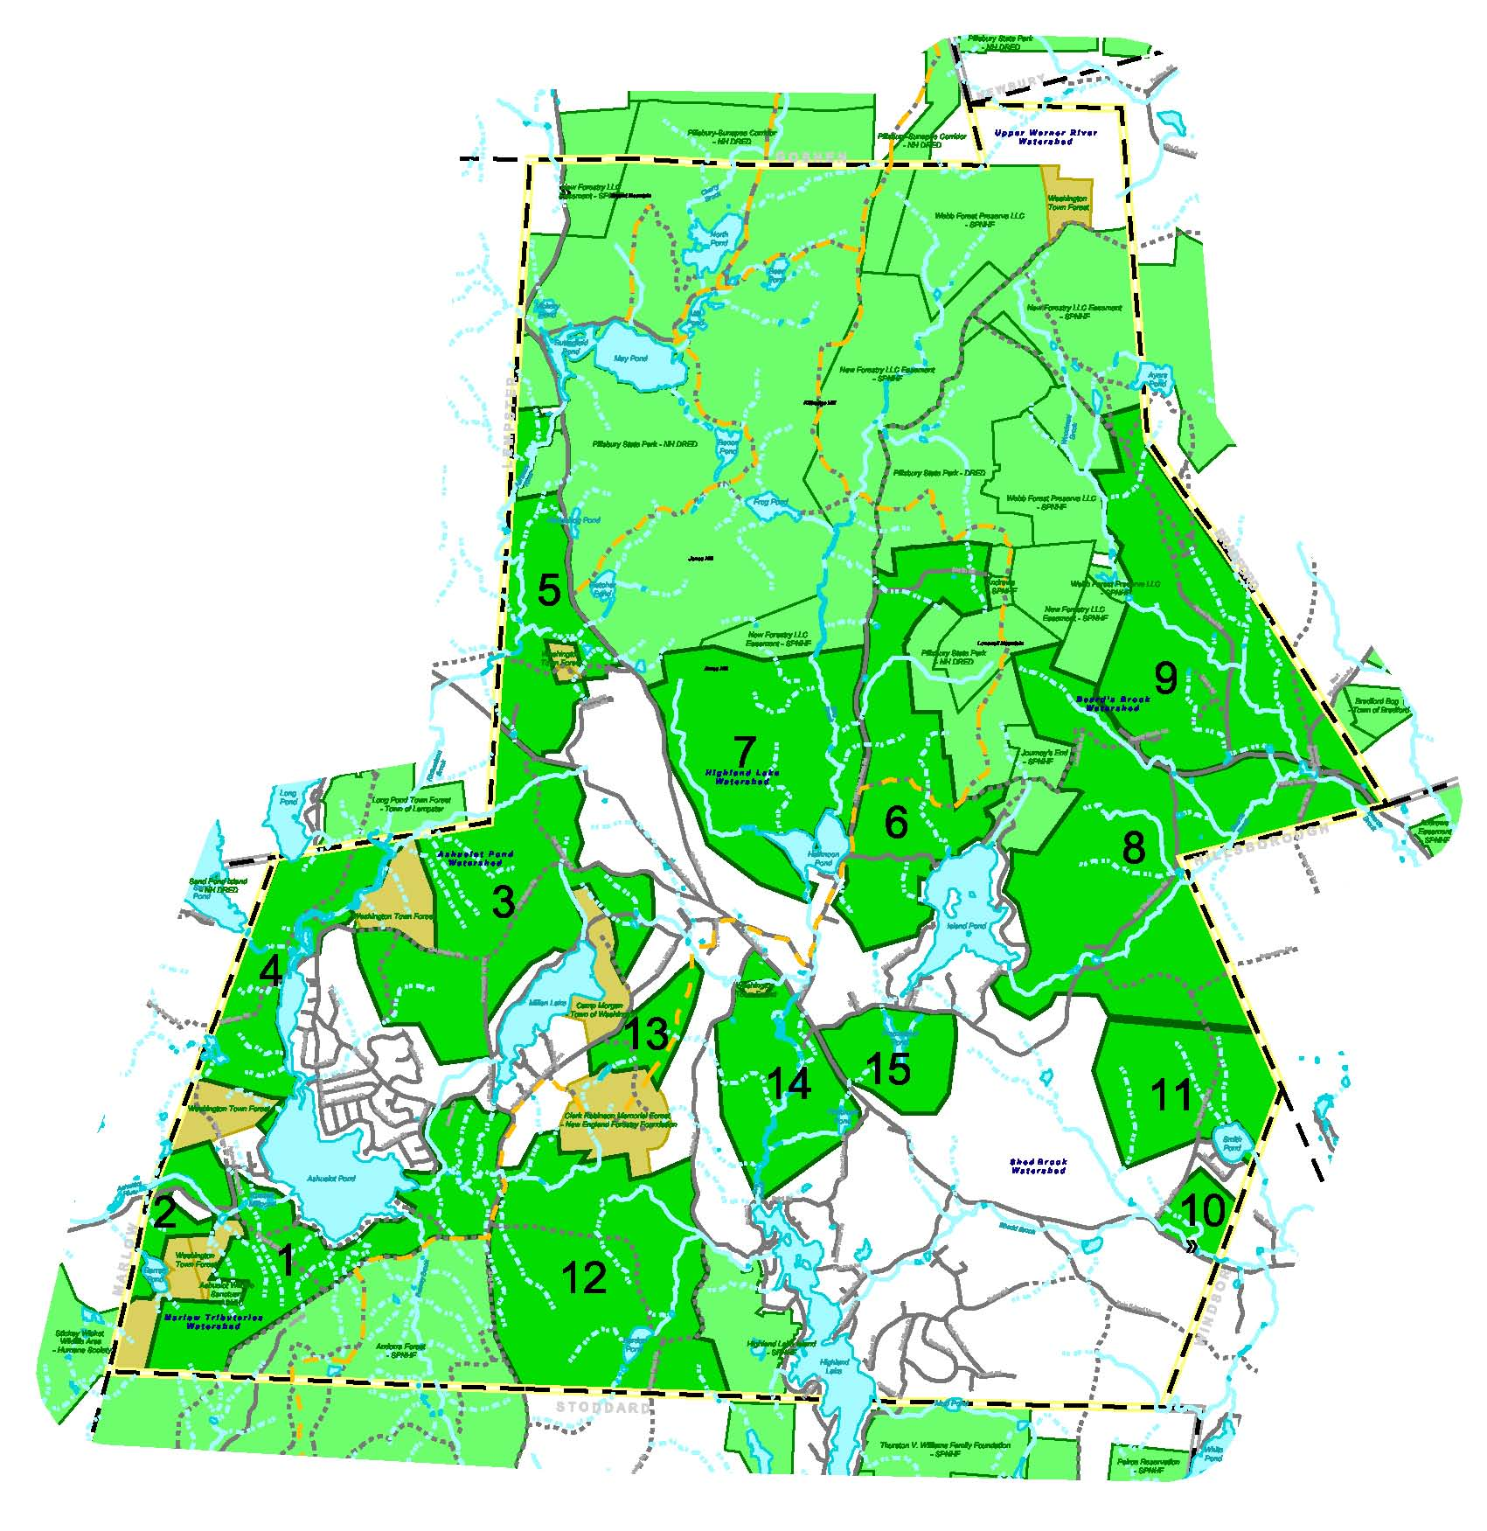

A. The Ashuelot River Headwaters Focus Area

From the headwaters at Butterfield Pond in Pillsbury State Park, the Ashuelot flows southwest into the Town of Lempster, then back across the line into Washington, and continues more-or-less southwesterly through Ashuelot Pond and Russell Mill Pond and into the Town of Marlow, ultimately arriving at the Connecticut River in Hinsdale.

Much of the upper-most stretch of the river, the so-called Ashuelot Headwaters area, is in Washington. This is the only stretch of the river that is classified as “Natural” by the New Hampshire Rivers Management and Protection Program – in recognition of its unspoiled, intact condition. All other stretches are classified as either “Rural” or “Community”. Portions of the river support populations of the Globally Rare Dwarf Wedge Mussel, and exemplary flood plain forest communities. The U.S. Fish & Wildlife Service identified the Ashuelot as important for the restoration of the fishery for anadromous fish species including river herring, salmon and shad. This stretch of the Ashuelot River and the streams that flow into it are of considerable importance to the ecological health of river not only in Washington, but also to the downstream communities that depend on it.

This area is recognized as being a priority for land conservation by the Land Conservation Plan for the Ashuelot River Watershed study, the Ashuelot River Corridor Management Plan, the Quabbin to Cardigan Conservation Collaborative Report, and the NH Fish & Game Wildlife Action Plan.

1. Starks Hill / Ashuelot Pond CPA

Description of Area

This completely undeveloped, forested area extends from the Stoddard / Washington Town line northeasterly across Russell Mill Pond Road to the south of Ashuelot Pond, and stretches east to King Street. Well drained and relatively steep in places, it includes flanks and the 1878-foot peak of Starks Hill. The area abuts a Society for the Protection of NH Forests conservation easement, the Audubon Society’s Ashuelot Wildlife Sanctuary, and Barrett Pond Town Forest.

Benefits of Conservation

Surface Water Quality – This area is especially important for the protection of the watersheds of Ashuelot Pond, Barrett Pond and the Ashuelot River. 20 undeveloped stream courses cross the area; these are sources to Barrett Pond, Russell Mill Pond and Ashuelot Pond. Several streams that flow directly northward into the Ashuelot River also originate from this area, and the Ashuelot River mainstem itself also passes through the western end of this area. Protection of this important area would help maintain the water quality of the river and the ponds that are supplied by it.

Flood Damage Prevention – 92 acres of flood-prone land associated with two source streams at the eastern end of Ashuelot Pond are contained in this Conservation Priority Area. Property damage and personal injury could be prevented by conserving this area, thus excluding development in this flood prone zone.

Forestry and Agricultural Productivity – Almost half of the area has Soils of Local Significance or Prime Agricultural Soils. The area is also especially productive for forestry, with about half of the area having Important Forest Soils, most notably Class IA that is highly suitable for northern hardwood production. Land conservation in this area would protect these productive and economically valuable soils from conversion, and reserve them for future productive use.

Biodiversity / Wildlife – The Wildlife Action Plan maps much of this area as significant for wildlife on a state-wide and ecological region. This un-fragmented forest area is very important for the large ranging wildlife species such as moose, otter and bobcat which depend on large contiguous forest blocks. Only two floodplain forest priority wildlife habitat areas were mapped in Washington by the WAP, and a portion of one of them occurs in this area. Conservation of this area would provide a critical protected link for the wildlife that depends on it for habitat, and protect this important and locally uncommon floodplain forest.

Wetlands - 34 acres of wetlands occur in this Conservation Area, primarily associated with the streams to the east and west of Ashuelot Pond. In particular, the wetlands to the east are in a flood prone area. Wetlands are valuable as wildlife habitat, but also for the storage of flood waters, buffering inputs of sediments. Protection of this wetland area would help maintain water quality in Ashuelot Pond and limit damage due to flooding.

Recreation - Snowmobile trails follow Russell Mill Pond Road, a Class VI Town road, as well as the entire southeast boundary of this Conservation Priority Area via Jefts Road. Winter recreation opportunities made possible by the five snowmobile trails totaling about three miles in length in this area, and future trail relocation options would be preserved by land conservation in this area.

Historic and Cultural – The Site of the second location of Old #3 School is situated at the north end of this Conservation Priority Area. The fully restored and internationally significant first Seventh Day Adventist Church and Cemetery are located directly across the road from this area as well, on King Street. The undeveloped, rural setting of these important historic sites would be preserved by land conservation in this area.

Scenic Assets – The rural road, Jefts Road, forms the southwest boundary of this area, and travels south into Stoddard. Undeveloped frontage on Marlow Road near Russell Mill Pond is also included in this Conservation Priority Area. Undeveloped shoreline of Ashuelot Pond would be protected for the scenic, water quality and ecological values it provides. The entire undeveloped shoreline of pristine Barrett Pond would also protected by the conservation of this area.

Connections and Buffers – This area forms a critical open space link between two existing conservation areas and a Town forest: the 11,000 acre Andorra Forest easement held by the Society for the Protection of NH Forests, the Audubon Society’s Ashuelot Wildlife Sanctuary, and Barrett Pond Town Forest. The collective conservation values of the Town Forest and the conservation lands in this area would be enhanced by land conservation in this area.

2. Barrett Pond CPA

Description of Area

The valley of the Ashuelot River is framed by hills to the south and north in this Conservation Priority Area. The area extends from the western boundary at the Marlow / Washington Town line, easterly to Marlow Road near Russell Mill Pond, and south to Barrett Pond.

Benefits of Conservation

Surface Water Quality – Over a half mile of the mainstem of the Ashuelot River passes through this Conservation Priority Area. This stretch of the river is 3rd Order. Two other streams also cross this area including a source tributary of the Ashuelot. The ecological integrity of this stretch of the Ashuelot River and its undeveloped upland buffer and associated wetlands would be maintained by focusing land conservation efforts in this sensitive area.

Flood Damage Prevention – Four acres of flood prone area occur along the Ashuelot River at the western edge of this Conservation Priority Area. Recent historic flood events in the general area underscore the real threat that streams and rivers can pose in areas prone to flooding. Land conservation here would be prudent to prevent property damage and personal injury by guiding development away from this area.

Forestry and Agricultural Productivity – About 1/3 of this Conservation Priority Area has Important Forest Soils, and/or Agricultural Soils of Local Significance. Once productive soil areas are converted to uses other than forestry and agriculture, their productive potential is essentially eliminated forever. Land conservation in this area would help protect the productive potential of these forest soils and the economic benefits they provide.

Biodiversity / Wildlife – Barrett Pond and another un-named wetland that the Ashuelot River flows through are Marsh & Shrub Wetland Priority Habitat areas mapped by NH Fish & Game in their Wildlife Action Plan. Blandings Turtle, American Woodcock and Sedge Wren are three of the species of conservation concern that are potentially supported by this significant habitat. 36 acres of the Wetland Priority Habitat Floodplain Forest mapped in the Wildlife Action Plan also are located in this Conservation Priority Area in association with the Ashuelot River. The Jefferson Salamander, Wood Turtle and Cerulean Warbler are some of the species of conservation concern that are known to depend on the habitat that Floodplain Forests provide. Only two Floodplain Forest areas are mapped in Washington. Land conservation in this area would protect much of the important Flood Plain wildlife habitat area, and the unprotected remainder of the Barrett Pond Marsh habitat area.

Historic and Cultural – The site of the old #7 School and an old cemetery are located in this Conservation Priority Area in an undeveloped area near Marlow Road. These cultural legacies hearken from a time when farms and mills were active and widespread, and transportation was slower. Land conservation would help preserve these reminders of early Washington, and preserve the rural setting around them.

Scenic Assets – This area is the entrance to Washington from the southwest in Marlow. A half a mile of undeveloped road frontage on Old Marlow Road, much of it contiguous to the Ashuelot River would be protected by land conservation in this Conservation Priority Area.

Connections and Buffers – This Conservation Priority Area is strategically located between Barrett Pond Town Forest, Huntley Mountain Town Forest and the Orenda-Stickey Wicket I Wildlife Sanctuary in Marlow owned by the U.S. Humane Society. Land conservation in this area would contribute to the existing protections to natural resources represented by these conservation and public lands by enlarging this block of open space land.

3. Farnsworth Hill CPA

Description of Area

The Farnsworth Hill Conservation Priority Area extends from Old Marlow Road and Lempster Road close to Washington Village, to the Lempster Town line and highlands of Farnsworth Hill to the west, and to the north of Millen Lake to the south. The peaks of three hills including Farnsworth rise northward from Millen Lake before descending toward Lempster Town Forest. Numerous farm fields along roads in this area lend a pastoral flavor to this quiet corner of Town.

Benefits of Conservation

Surface Water Quality – This area is of very high importance for the protection of the water quality of Ashuelot River. Eight undeveloped stream reaches, including source streams for Ashuelot Pond and the Ashuelot River mainstem, originate or pass through here. Protection of this area would help maintain the water quality of the river and of Ashuelot Pond that is supplied by it.

Ground Water – A portion of the wellhead protection area associated with the public drinking water supply at Washington Elementary School is included in this Conservation Area. The remainder of the protection area extends to Millen Pond, and the Camp Morgan Town property. Land conservation in this area would complete the protection of this important water supply by preventing contrary uses that could potentially degrade its quality for drinking water.

Forestry and Agricultural Productivity – About 1/3 of this area has Prime Agricultural Soils or Soils of Local Significance. 60 of these acres are actively used for productive agriculture. Almost the entire area also has Important Forest Soils, primarily type 1A, most suitable for northern hardwood production, but also type 1B, suitable for mixed softwoods and hardwoods. Land conservation in this area would help protect the productive potential of these forest soils and the economic benefits they provide.

Biodiversity / Wildlife – The Wildlife Action Plan maps much of this area as significant for wildlife on a state-wide and ecological region. This un-fragmented forest area is very important for the large ranging wildlife species such as moose, otter and bobcat which depend on large contiguous forest blocks. A pristine example of the Upper Perennial Riparian Ecological System, associated with the stream drainages of the Ashuelot mainstem and associated wetlands, has also been documented in this area. This unusual natural system and the biodiversity it supports would be protected by land conservation in this area.

Historic and Cultural – The old Thissell Cemetery and the site of the Old #4 School are located in this conservation priority area. Remnants of old Washington, these historic sites and the natural context around them would be protected by conserving this area for future generations to appreciate.

Rural Character – Four actively used farm fields and farm buildings are highly visible from the roads in this area. These uncommon and important surviving examples of Washington’s agricultural past would be preserved by land conservation in this area.

Scenic Assets – This area has almost four miles of undeveloped frontage on both sides of four roads: Old Marlow Road, Farnsworth Hill Road, and two un-named roads. The flanks of 1,831 ft. high Farnsworth Hill are visible from the waters and south shore of Millen Lake. The natural forested quality of these features and the scenic enjoyment they offer would be preserved by land conservation in this area.

Recreation – Nearly four miles of Snowmobile Trails cross this Conservation Priority Area. Winter recreation opportunities and trail relocation options would be protected by the conservation of these trail corridors, which may also available for cross country skiing and at other times of the year for hiking.

Connections and Buffers – This Conservation Priority Area is part of a large un-fragmented forest block that includes Farnsworth Hill Town Forest, Lempster Town Forest and the Camp Morgan Town property. The value of these public lands for conservation would be enhanced by land conservation in this large, un-fragmented area.

4. Huntley Mountain CPA

Description of Area

This virtually undeveloped corner of Washington, where it abuts the Towns of Marlow and Lempster, is in the heart of the Ashuelot headwaters. The entire eastern boundary of this conservation priority area is defined by frontage on both Ashuelot Pond and the Ashuelot River. The lower portions of the slopes that rise from the pond toward the top of Huntley Mountain and the Marlow/Washington Town line also contain very important high-yield aquifers. This area also abuts three Town Forests suggesting the possibility of enhanced protection through land conservation connections.

Benefits of Conservation

Ground Water – This CPA contains some of the most significant high-quality groundwater aquifers in the Town (about 50 acres), a resource that is very uncommon in Washington. It also contains a large proportion of land suitable for gravel wells for public drinking water supplies (about 20 acres). Land conservation in this area, along with the slopes above the aquifers would preserve this high-quality groundwater for potential future public drinking water supplies.

Surface Water Quality – Land conservation in this area would have direct benefits to the future water quality of both Ashuelot Pond and the Ashuelot River. 6,500 ft. of the river passes through this area on its way to Ashuelot Pond. There are also six undeveloped stream reaches, including direct source streams for the Ashuelot River and Ashuelot Pond. The slopes here are relatively steep – about 35% of the area has more than a 15% slope. Commercial or residential development would likely create soil disturbance in this relatively steep area; this could seriously degrade water quality. Virtually the entire length of the connecting stream between Sandy Pond and Ashuelot Pond also passes through this CPA.

Forestry and Agricultural Productivity – This CPA contains several areas of Important Forest Soils well suited to softwood and hardwood production, and a small area of Locally Important Agricultural Soils. Land conservation in this area would ensure that the productive capacity of these soils was maintained through the use of sustainable practices.

Biodiversity and Wildlife – The Wildlife Action Plan maps much of this area as significant for wildlife on a state-wide and ecological region. This un-fragmented forest area is very important for the large ranging wildlife species such as moose, otter and bobcat which depend on large contiguous forest blocks. Other species also benefit from the proximity of this area to wetlands and stream corridors. Land conservation in this vicinity would provide a critical protected link for the wildlife that depends on it for habitat. A pristine example of the Upper Perennial Riparian Ecological System, associated with the stream drainages of the Ashuelot mainstem, has also been documented in this area. This unusually intact natural system and the biodiversity it supports would be protected by land conservation in this area.

Wetlands – A diverse assemblage of wetland types is associated with the riparian zone around Ashuelot River in this area, including aquatic beds, deep emergent marshes, and forested swamps. Land conservation here would contribute to the value of these diverse wetlands by preserving the biodiversity that these wetlands represent.

Flood Damage Prevention – A 100 acre area near the Ashuelot River in this CPA is prone to flooding. Flood events in recent years underscore the threat that streams and rivers pose during periods of excessive precipitation. Land conservation would help prevent property damage and personal injury by guiding development away from this area.

Scenic Assets – This highly visible undeveloped ridge and flank of Huntley Mountain above the west shore of Ashuelot Pond is enjoyed by residents and visitors to the waters and shoreline of Ashuelot Pond. 2,000 feet of the undeveloped western shoreline of Ashuelot Pond proper are also included in this Conservation Priority Area. Land conservation in this vicinity would help preserve its value as a scenic resource enjoyed by all.

Recreation – The area also has two miles of undeveloped frontage on McKinnon Road, a Class VI Town road that extends from Washington into both Lempster and Marlow. This road is appropriate for hiking, skiing and bicycling. Land conservation of this area would help preserve this recreational opportunity for the residents of Washington and the general public.

Connections and Buffers – This Conservation Priority Area abuts Farnsworth Hill Town Forest, Huntley Mountain Town Forest and Long Pond Town Forest in Lempster. It also makes a connection between Huntley Mountain Town Forest and the shoreline of Ashuelot Pond. The collective conservation value of these public lands would be enhanced and increased by land protection in this large, un-fragmented area.

5. Codman Hill CPA

Description of Area

The wild highlands of the east side of this area on Rte. 31 provide a unique, rugged and undeveloped gateway to Washington from the north that has a character closer to the North Country, rather than to southern New Hampshire. Extending westward to the Lempster Town line and south to Lempster Mountain Road and Washington Heights Road, the headwaters of the Ashuelot River are virtually across the road from this area, at the source - the outlet to Butterfield Pond.

Benefits of Conservation

Surface Water Quality – Nearly 9,000 ft. of the undeveloped and unprotected headwater stretch of the Ashuelot River flow through this area. Land conservation here would help maintain the natural condition of this pristine river headwaters and its riparian corridor by preventing impacts and intensity of use resulting from new development and road building.

Flood Damage Prevention – This area contains 72 acres of Flood Prone area associated with the Ashuelot River. Recent historic flood events in the general area underscore the real threat that streams and rivers can pose in areas prone to flooding. Land conservation in this area would help prevent property damage and personal injury by guiding development away from this area.

Forestry / Agricultural Productivity – Most of this area has Important Forest Soils, especially those well suited to the production of northern hardwoods. Once productive soil areas are converted to uses other than forestry and agriculture, their productive potential is essentially eliminated forever. Land conservation in this area would preserve these most productive soils for continued, economically viable forest production.

Biodiversity / Wildlife – The Wildlife Action Plan maps much of this area as significant for wildlife on a state-wide and ecological region. This un-fragmented forest area is very important for the large ranging wildlife species such as moos, otter and bobcat which depend on large contiguous forest blocks. Other species also benefit from the proximity of this area to wetlands and stream corridors. A rare example of old growth northern hardwood forest has been observed in this area as well. A pristine example of the Upper Perennial Riparian Ecological System, associated with the stream drainages of the Ashuelot mainstem, has also been documented in this area. This unusual natural system and the biodiversity it supports would be protected by land conservation in this area.

Wetlands – An extensive complex of wetland types frame the mainstem of the Ashuelot as it flow south through this area. Alluvial alder shrubland and emergent marsh wetland types occur here. Land conservation here would contribute to the value of these wetlands by preserving the biodiversity that these wetlands support.

Historic and Cultural – A unique geological curiosity known since the early days of Washington as Devil’s Chair, is located in this Conservation Priority Area. Near the Lempster Town line on the Class 5 road/trail Twin Bridges Road, is an unusual bridge with abutments that were constructed many years ago from rock, supporting two spans that connect in the middle on ledge. The bridge is located where the drainage between two broad wetlands is constricted, and offers sweeping views in both directions. These important cultural features could be protected by focusing land conservation in this area.

Rural Character – The wild, primitive Class V Road Twin Bridges Road is used by hikers, and offers views of large wetlands, old growth hardwood forest, and a variety of mature second growth forest with no indications of settlement. Such untouched remnants of pre-settlement and early settlement conditions are very uncommon today. These legacies could be protected by land conservation.

Recreation – Over a mile of active Snowmobile Trails pass through the core of this
Conservation Priority Area. Land Conservation in this area would protect this remote winter recreation opportunity, and provide for alternative trail routes should this be necessary.

Scenic Assets – This area has over a mile of undeveloped frontage on NH Rte. 31, directly across the road is Pillsbury State Park. The peak of Farnsworth Hill is also located in this area close to Rte. 31. This unique, high country natural gateway to Washington could be preserved for it’s scenic beauty for present and future motorists by targeting land conservation there.

Connections and Buffers – This large un-fragmented forest block abuts New Road Town Forest, Pillsbury State Park, Farnsworth Hill Town Forest and the Camp Morgan Town property. By protecting land around and between these existing conservation and public lands, the wildlife and ecology of these areas will be enhanced.

B. Central Washington Focus Area

Description of General Area

Located at the heart of Washington and close to Washington Village, this area is characterized by lakes, hilly topography, extensive forests and secluded streams and wetlands. Remarkably undeveloped and natural, it is the southern extension of the rugged highlands that include Jones Hill, Kittredge Hill and Lovell Mountain in Pillsbury State Park to the north. Several hiking and snowmobile trails cross this area and provide access to Pillsbury and other conservation lands.

This area is recognized as being a priority for land conservation by the Quabbin to Cardigan Conservation Collaborative Report, and the NH Fish & Game Wildlife Action Plan.

6. Island Pond CPA

Description of Area

This large Conservation Priority Area in the geographic center of the Town extends from the lower western flanks of Lovell Mountain in Pillsbury State Park west to Halfmoon Pond Road, and south to the western side of Island Pond. Characterized by relatively steep terrain, portions of the watersheds of Bog Brook, Island Pond and Halfmoon Pond are included in this forested area.

Benefits of Conservation

Surface Water Quality – Seven undeveloped stream reaches that directly supply Halfmoon Pond and Island Pond occur in this area. Land protection here would have direct benefits to the future water quality of both Island Pond and Halfmoon Pond, and would have secondary benefits to the water quality of Highland Lake.

Forestry and Agricultural Productivity – About half of this land area has the two most Important Forest Soils IA and IB that are highly suitable for northern hardwoods and for mixed hardwoods/softwoods. There are also some areas with Prime Agricultural Soils and Agricultural Soils of Local Significance. Considering the forest productivity of this area, land conservation is recommended to help keep the land economically viable for commercial forestry and agriculture.

Biodiversity / Wildlife – According to the NH Fish & Game Department’s Wildlife Action Plan, Wildlife Habitat of Highest State-wide Condition Rank occurs in the area, as well as Supporting Habitat. This undeveloped, un-fragmented wildlife corridor between the waters of Island Pond and Halfmoon Pond would also be protected by land conservation in this area.

Wetlands – Several peatlands occur in this Conservation Priority Area. Wetlands of this general type are uncommon in this part of the state, and are considered a Priority Habitat for Wildlife by the NH Fish & Game Department. Protection of these unusual wetlands and their surrounding upland habitat by the use of land conservation would be help protect the wildlife that is known in general to depend on them, including the Ringed Boghaunter Dragonfly and Palm Warbler.

Historic and Cultural – At the end of the maintained portion of Halfmoon Pond Road is the site of an old Town School. Land conservation would help maintain the rural context of this historical feature, located at the edge of what is now in a remote and unsettled area.

Recreation – The Monadnock-Sunapee Greenway Trail route crosses through the heart of this Conservation Priority Area, and also follows the boundary on Halfmoon Pond Road for a total of 11/2 miles. A mile and a half of Snowmobile Trial corridor also crosses this area in two locations, making connections to Pillsbury State Park. Land conservation here would help preserve these popular recreational assets, and could provide for alternative routes and new trails in the future.

Scenic Assets – Undeveloped shoreline of Island Pond and Halfmoon Pond would be protected by land conservation in this area. Such protection would provide scenic enjoyment not only of the residents of these ponds, but also of hiking and boating visitors to the area.

Connections and Buffers – Situated as it is with some five miles of boundaries on other existing conservation lands, land conservation in this area would make significant contributions to the enhancement of combined conservation area of Pillsbury State Park, the New Forestry LLC easement and Journey’s End Reservation (SPNHF). Un-fragmented open space between Island Pond and Halfmoon Pond would also be protected where none is currently protected.

7. Ames Hill / Halfmoon Pond CPA

Description of Area

This Conservation Priority Area is characterized by relatively steep terrain in the northwest, northeast and southwest, framing the unspoiled corridor of upper Bog Brook and its extensive wetlands, as it flows south into Halfmoon Pond. Bordered by Halfmoon Pond Road to the east, North Main Street to the west, and Pillsbury State Park to the north, its proximity to Washington Village suggests recreational connections through un-fragmented forest to Halfmoon Pond and beyond to Pillsbury State Park.

Benefits of Conservation

Surface Water Quality – Three un-named, undeveloped stream reaches are included in this area, all sources to 75-acre Halfmoon Pond. This includes the entire length of the two largest source streams to the pond. A mile and a half of Bog Brook also is included in this area, the last remaining un-protected section above Halfmoon Pond. Land conservation in this Conservation Priority Area would protect these undeveloped riparian corridors that maintain the water quality of Halfmoon Pond, and secondarily the water quality of Highland Lake further downstream.

Flood Damage Prevention – A significant 72-acre area that is prone to flooding is located in the middle of this area in association with Bog Brook. Land conservation there would help prevent property damage and personal injury by guiding development away from this area. It would also help maintain the stability of the immediate watershed for the flood mitigation services this would provide.

Forestry and Agricultural Productivity – More than half of this Conservation Priority Area has Important Forest Soils, including the largest single area in Washington of soil most suitable for the growing of White Pine and other softwoods. About 20% of the area also has Important Agricultural Soils, including Prime Agricultural Soil. Land conservation in the area would help protect these economically valuable soils and their capacity for forestry and agricultural production.

Biodiversity / Wildlife – The majority of this Conservation Priority Area is mapped by the NH Fish & Game Department as Wildlife Habitat of Highest State-wide Condition Rank. Large, un-fragmented by any roads, and currently providing a habitat corridor between Pillsbury State Park and Halfmoon Pond, as well as along undeveloped Bog Brook and its wetlands, land conservation in this area should be a priority.

Wetlands – Over 70 acres of diverse wetlands occur in this Conservation Priority Area. In particular this includes the largest example (30 acres) of the Peatland type in Washington, as well as a large complex of Marsh wetlands that for their combined size and condition are both considered Priority Habitat at risk in the LIP Focus Area that includes Washington. Land conservation here would directly benefit these important, intact habitats and the wildlife that depend on them, and funding may be available from the LIP program for this effort.

Recreation – ¾ of a mile of a Snowmobile Trail corridor cross through this Conservation Priority Area, and a section of the Monadnock-Sunapee Greenway regional hiking trail follows its eastern boundary along Halfmoon Pond Road. Land conservation here would help protect these trail corridors and the recreational benefits they provide, as well as allowing for appropriate alternative routes should they be desirable in the future.

Scenic Assets – The peak of 2,140 foot Ames Hill is located in the northern part of this area, visible from Halfmoon Pond and Island Pond. 8,000 ft. of continuous undeveloped shoreline of Halfmoon Pond in this area provides significant scenic, water quality and ecological benefits. Land conservation in this Conservation Priority Area would protect these high-quality resources for current and future residents and visitors.

Connections and Buffers – Entirely bounded on the north by nearly 2 miles of the boundary of Pillsbury State Park, land conservation in this area would enhance and enlarge the contiguous conservation area of Pillsbury State Park and the other conservation lands adjacent to it. It would also protect the existing undeveloped linkage between the Park and Halfmoon Pond.

C. East Washington Focus Area

Description of General Area

Driving to East Washington from the south in Hillsboro, a motorist passes extensive open fields, and 18th and 19th century farm houses and barns, finally arriving at the quiet crossroads village center with its old white churches, school and mill pond. A large working farm with cornfields dominates the western end of this valley, a unique agricultural landscape in an otherwise forested highland setting that stretches northward to the ridges to the north. This diverse area extends from the flanks of Lovewell Mountain and Pillsbury State Park east to the Bradford Town line, south to the Hillsboro Town line and west to Island Pond.

This area is recognized as being a priority for land conservation by the Quabbin to Cardigan Conservation Collaborative Report, and the NH Fish & Game Wildlife Action Plan.

8. Beards Brook CPA

Description of Area

This Conservation Priority Area extends from East Washington village south to the Hillsborough Town line, and west to Lovell Mountain and Island Pond. Serving as the gateway to old East Washington village from both center Washington and from Hillsboro, it is a very special corner of Town.

Benefits of Conservation

Surface Water Quality – Currently the watershed of both the south and north branches of Beards Brook are mostly unprotected by formal land conservation. This Conservation Priority Area contains virtually the entire length of both branches of Beards Brook, from their origins at Island Pond and on the southeast flank of Lovewell Mountain, past the confluence with Woodward Brook at Mill Pond, and south to the Hillsboro Town line. As recent issues with pollution in Mill Pond underscore, water quality is an important resource that needs enhanced protection. Land conservation in these important watersheds would help maintain the quality of these streams and the water bodies associated with them.

Ground Water – 167 acres of high yield aquifer are located in this Conservation Priority Area, the majority of the largest single high-quality aquifer in Washington. This is also associated with 85 acres of Potentially Favorable Gravel Well Area. Between this area and the Woodward Brook Conservation Priority Area just to the north, there is more high yield aquifer than all the rest of the areas in Washington combined. A clean and reliable source of ground water is one of the most important natural resources a Town can have. With climate change a widely accepted fact, and the consequences unknown, prudence would dictate the protection of high quality drinking water supplies whenever possible. The best way to do this is with the comprehensive protection that land conservation provides.

Flood Damage Prevention – 66 acres of Flood-Prone area are located along the Beards Brook riparian corridor south and east of East Washington Road. Recent severe weather events have caused catastrophic floods in Towns immediately to the west of Washington, highlighting the potential that even small streams can have during historic floods. Land conservation here would help prevent property damage and personal injury by guiding further development away from this area.

Forestry and Agricultural Productivity – There are 72 acres of actively used farmland in this Conservation Priority Area, the largest concentration of active farming in the Town. There are also Prime Agricultural Soils, Soils of Statewide Significance and Soils of Local Significance in this area. About half the area of this Conservation Priority Area has Important Forest Soils. Land conservation in the area would help protect these economically valuable soils and their capacity for forestry and agricultural production.

Biodiversity / Wildlife – The majority of this Conservation Priority Area is mapped by the NH Fish & Game Department as Wildlife Habitat of Highest State-wide Condition Rank. Included in this mapped area is the largest example of the Large Grassland Priority Habitat type in Washington (214 acres). Numerous species that are in decline and / or of conservation concern including northern harrier, horned lark, purple martin, northern leopard frog and wood turtle utilize larger grasslands such as the ones in East Washington. This Conservation Priority Area also has examples of Peatland and Marsh complex, two other Priority Habitat types mapped by the Wildlife Action Plan. Land conservation in the areas of these grasslands, wetlands and the surrounding landscape would help maintain their special wildlife habitat and biodiversity values.

Historic and Cultural – This part of Washington is particularly rich with cultural and historic features. An old school house, known variously in the literature as District 5 is located near East Washington Road. Near the outlet of Island Pond the stone foundation of an Old Mill is still evident today. Two other mills were once located in East Washington, one at the site of the Lovell Creamery, and the other known as the Carr’s Mill site. Land conservation in this area would help preserve these sites of local historic value.

Rural Character – East Washington village, with its old churches, school, and residences, still appears much as it must have 100 years ago. As a gateway to the Town from the southeast in Hillsboro, land conservation would help preserve the rural character of this village that has become a signature of the Town’s identity.

Recreation – Over two miles of snowmobile trails cross this area, making connections to trails in Hillsboro and to conservation lands to the west. In the center of East Washington village, Mill Pond has a public swimming beach. Land conservation in this part of town would help maintain the trail corridors and provide areas for potential relocation if necessary. It would also provide comprehensive protection of the drainages of Beards Brook and the water quality of the public beach at Mill Pond.

Scenic Assets – Picturesque East Washington village and its setting below the slopes of Lovell Mountain are exceptional scenic assets to the Town. Land conservation here would help maintain the scenic qualities and rural landscape context of this special area.

Connections and Buffers – This area abuts three existing conservation properties: the SPNHF Journey’s End Reservation, Pillsbury Sate Park and the New Forestry LLC Easement (SPNHF). There is currently a gap in the protection of the southeast flank of Lovell Mountain, at the headwaters of the north branch of Beards Brook. Land conservation in this area would consolidate the protection of Lovewell Mountain, the most visible landform in Washington, as well as the headwaters of Beards Brook.

9. Woodward Brook CPA

Description of Area

This Conservation Area is bounded by the Bradford town line to the east, by East Washington Road to the south, and by conservation lands and the base of the Lovell Mountain highlands to the west and north. A diverse array of landscapes is represented here, from the wild upper drainage of Woodward Brook to the pastoral setting of old East Washington village. This area and the nearby Beards Brook area are the first sights a visitor sees when entering the Town from the south in Hillsboro.

Benefits of Conservation

Surface Water Quality – Six undeveloped stream reaches flow through this Conservation Priority Area, most notably Woodward Brook and its tributaries. Woodward Brook is a wild, high-quality stream that supports wild trout. Its headwaters are largely protected by conservation to the north. Woodward Brook also supplies water to Mill Pond with its public swimming area. Land conservation in this area would help ensure that this major stream maintains its pristine quality.

Ground Water – This Conservation Priority Area contains 60 acres of High Yield Aquifer area and 27 acres of Potentially Favorable Gravel Well Area. The largest high-quality potential drinking water source in the Town is located in this area and the Beards Brook Conservation Priority Area. A clean and reliable source of ground water is one of the most important natural resources a Town can have. The best way to protect this critical resource for future use is with the comprehensive protection that land conservation provides.

Flood Damage Prevention – A total of 37 acres of Flood Prone area occur in two locations in this Conservation Priority Area, associated with the upper and lower portions of Woodward Brook. Land conservation there would help prevent property damage and personal injury by guiding development away from this area. It would also help maintain the stability of the immediate watershed for the flood mitigation services this would provide.

Forestry and Agricultural Productivity – 47 acres of agricultural land are actively used in this Conservation Priority Area. There are also one area of Prime Agricultural Soils, and others of Agricultural Soil of Statewide Significance and Local Significance. Nearly the entire area also has Important Forest Soils. Land conservation in the area would help protect these economically valuable soils and their capacity for forestry and agricultural production.

Biodiversity / Wildlife – Included in this mapped area is a continuation of the largest example of the Large Grassland Priority Habitat type in Washington (214 acres) which is primarily located in the nearby Beards Brook Conservation Priority Area. Numerous species that are in decline and / or of conservation concern including northern harrier, horned lark, purple martin, northern leopard frog and wood turtle utilize larger grasslands such as these in East Washington. NH Fish & Game has mapped almost this entire area as Wildlife Habitat of Highest State-wide Condition Rank. When combined with the nearby Beards Brook Conservation Priority Area this is the most significant block of priority wildlife habitat in Washington, and most of it is currently un-protected. This area also abuts the Bradford Bog with its globally rare Inland Atlantic White Cedar Swamp natural community. Land conservation in this area would help to protect the natural hydrology and water quality of Bradford Bog, and help protect the sensitive priority wildlife habitat areas from disturbance and alteration.

Historic and Cultural – The unusual geological feature Tipping Rock is located in the forest just to the east of this Conservation Priority Area north of the village of East Washington. Actually located a short distance to the east of the town line in Bradford, this curiosity has been a popular destination since early days. The old Methodist Church (1859) and old Calvinist Baptist Church (1877) still survive to this day on the north side of East Washington Village and contribute to the historic flavor of this part of Town. Land conservation would help maintain the rural landscape context of the village and its historic structures, and allow continued access to the Tipping Rock area.

Rural Character – East Washington Village is a stunning surviving example of an early American Town center, fully retaining the character of the rural life of old Washington as it must have been in generations past. Land conservation in this area would help retain a piece of Washington’s special rural quality by protecting the open space, rural context of the village.

Recreation – Over 3 1/2 miles of Snowmobile Trails cross this Conservation Priority Area. Woodward Brook supports a population of wild brook trout. Development and forestry can impact stream quality by increasing sedimentation and raising water temperature by clearing of streamside vegetation, reducing its suitability for trout. Land conservation in this area would protect the corridors of these trails, allow for relocation of the corridor if necessary or desirable, and maintain the quality trout fishery supported by the wild freestone stream Woodward Brook.

Connections and Buffers – This Conservation Area abuts several existing conservation lands: Pillsbury State Park, Journey’s End Reservation (SPNHF), the Webb easement (SPNHF), the New Forestry LLC easement (SPNHF), and the Bradford Bog conservation area (Town of Bradford). Enhancement and enlargement of the contiguous conservation area of these properties would increase their value for the conservation services that they provide. Land conservation targeted specifically in areas that would increase this existing conservation base is recommended.

D. Southeastern Washington Focus Area

Description of General Area

This sparsely settled corner of Town is Washington’s window to the world, as most travelers drive right by it on Rte. 31 from Hillsboro and Windsor to get there. This focus area has a wide variation in elevation, from the 1,635 ft. high Kingsbury Hill summit to the wide wetland valley framing Shedd Brook at 984 ft., one of the lowest points in Town.

This area is recognized as being a priority for land conservation by the Quabbin to Cardigan Conservation Collaborative Report, and the NH Fish & Game Wildlife Action Plan.

10. Shedd Brook CPA

Description of Area

This relatively small Conservation Priority Area is the gateway to Washington from the southeast on Rte. 31. The broad vista of an extensive wetland to the north, and the forested peaks of Jones Hill and Kingsbury Hill to the north make this a special place, and a welcoming introduction to visitors to Washington. But this area has more than scenic value, as a significant aquifer underlies a biologically important wetland complex that Shedd Brook that flows through on its way to Hillsboro.

Benefits of Conservation

Surface Water Quality – Over a mile of the undeveloped riparian corridor of the chief stream in southeast Washington, Shedd Brook, and a major tributary are included in this Conservation Priority Area. The context for these streams is a very large wetland complex. This area is bordered by two public roads, which already introduce impacts from sediments and road salt to this area. Land conservation in this riparian wetland area would help maintain the quality of these streams.

Ground Water – 23 acres of a large High Yield Aquifer that extends into Windsor is included in this Conservation Priority Area. This is one of the three most important high-quality groundwater sources in the Town. As population growth continues in the Town and region, reliable sources of drinking water will become more important. The most effective way to protect this critical resource for future use is with the comprehensive protection that land conservation provides.

Flood Damage Prevention – This relatively broad, level area has 34 acres of Flood Prone area associated with Shedd Brook and its wetlands. These wetlands help mitigate for the impacts of floods as they store these waters and slow their passage downstream, reducing potential damage from floods. Land conservation here would help prevent property damage and personal injury by guiding further development away from this area, and helping to keep these wetlands and their forested buffers intact.

Biodiversity / Wildlife – This Conservation Priority Area is particularly important as wildlife habitat, containing three of the four Wildlife Action Plan Priority Habitat types that occur in Washington. It contains one of the largest occurrences of the Marsh and Shrub Wetland Priority Habitat type mapped by the Wildlife Action Plan in Town. American Woodcock, Blandings Turtle, Northern Harrier, Osprey and Sedge Wren are just a few of the species of conservation concern that are supported by this wetland suite. A large portion of the largest Floodplain Forest habitat also is included in this area. Cerulean Warbler, Silver-haired Bat and Northern Leopard Frog are some of the species of conservation concern known to depend on such uncommon habitat. Finally, the uncommon Peatland habitat type occurs as a part of the wetland complex here. Most of the wetland community types within this suite of wetlands are uncommon or rare State-wide. Wildlife habitat in general in this area was ranked by the Wildlife Action Plan as of Highest State-wide Condition Rank. Land conservation in this area would help to protect these sensitive priority wildlife habitat areas from disturbance and alteration.

Wetlands – A 44 acre complex of wetlands, among the most diverse complex assemblage in Washington is a major feature of this Conservation Priority Area. This large area not only provides scenic enjoyment and unusual wildlife habitat, but also control and processing of flood waters. Land conservation in this area would help protect this important wetland area for the variety of public and biological benefits that it provides.

Rural Character – The first view of Washington from Rte. 31 leaving Windsor is the sweeping panorama of this wild landscape of wetlands and forested hills. Remarkably natural and unspoiled to this day, it harkens back to the days when settlers first came to the place they later called Washington. Land conservation in this small, but important entrance to the Town would help maintain this wild, natural character that is a trademark of the Town.

Recreation – A half mile of Snowmobile Trail corridor passes through this Conservation Priority Area, connecting with the Smith Pond area and north Hillsborough, and Stoddard to the south. Land conservation in the Shedd Brook Conservation Priority Area would help maintain this winter recreation opportunity.

11. Smith Pond CPA

Description of Area

This Conservation Priority Area is bounded by Smith Pond to the south, by the Windsor and Hillsboro Town lines to the east, and extends northward to include the peak of Kingsbury Hill. This quiet, un-populated corner of Town has only one road, Class 6 Smith Road that passes through towards the north over the gap between Kingsbury and Jones Hills.

Benefits of Conservation

Surface Water Quality – The entire undeveloped length of both streams that are the sources to Smith Pond, and a portion of a major tributary to Shedd Brook are located in this Conservation Priority Area. The undeveloped east shoreline of Smith Pond is also included. Protection of this area by the use of land conservation would help maintain the water quality of these streams, and of Smith Pond and Shedd Brook that are supplied by them.

Forestry and Agricultural Productivity – Most of this Conservation Priority Area has Important Forest Soils, most notably Class IA that is highly suitable for northern hardwood production. About 25% of the area also has Agricultural Soils of Local Significance. Highly productive agricultural soils are uncommon in Washington. Land conservation in this area would help protect the productive potential of these forest and agricultural soils and the economic benefits they provide.

Biodiversity / Wildlife – NH Fish & Game has mapped almost this entire area as Wildlife Habitat of Highest State-wide Condition Rank. Its proximity to the Shedd Brook and Beards Brook Conservation Priority Areas suggest wildlife habitat corridors that should be protected from fragmentation and human disturbance. Land conservation in this area would help support wildlife by the protection of habitat.

Historic and Cultural – The site of old #8 or #10 school is located in this Conservation Priority Area along Smith Pond Road (sources are unclear as to which number school it was). The setting is a Class 5 Road that currently also serves as a trail in an undeveloped part of Town. Preserving the historic, rural setting of this historic site and its surroundings would best be done by conserving the land in the vicinity.

Recreation – Nearly a mile of Snowmobile Trail corridor crosses this Conservation Priority Area. Smith Pond, the eastern shore of which is included in this area has a cold water fishery and a public boat access. Land conservation here would help maintain the quality of the pond for fishing, and allow for continued use and potential relocation of winter recreational trails.

Scenic Assets – The peak of Kingsbury Hill, that is clearly visible from Rte. 31 is within this Conservation Priority Area. The undeveloped eastern shore of Smith Pond is also enjoyed by the residents and visitors to the pond. Land conservation would protect these special scenic qualities for future generations to enjoy.

Connections and Buffers – There are currently no existing conservation lands contiguous to this Conservation Priority Area. However, initiating land conservation in this area would help protect this undeveloped and otherwise unprotected southeast part of Town, and make connections with the Shedd Brook and Beards Brook proposed Conservation Priority Areas.

E. South Central Washington / Highland Lake Focus Area

Description of General Area

The unifying theme for this Conservation Focus Area is the watershed of Highland Lake. This very long (6 miles, 712 acres) and narrow lake, very popular with seasonal residents, is primarily in the Town of Stoddard, but the northern ¼ of the lake and much of the watershed extends into Washington. Bog Brook, the major northern source for the lake forms the spine of this area, which is characterized by highlands that frame the eastern and western sides of the lake basin and its source brook. Much of the lake shore is densely populated, yet a short distance from the lake the setting is wild and roadless forest.

This area is recognized as being a priority for land conservation by the Quabbin to Cardigan Conservation Collaborative Report, and the NH Fish & Game Wildlife Action Plan.

12. Barden Pond CPA

Description of Area

This large, undeveloped area is an as yet unprotected portion of a large forested block in the highlands that extends from the Stoddard Town line northward to the Clarke Robinson Memorial Forest conservation area. Natural features of this area include the north slopes and summit of Healey Hill, and undeveloped Barden Pond and its surrounding natural landscape. It is bordered by the un-maintained Town roads King Street to the west and Barden Pond Road to the east. Wedged between the Andorra Forest easement and the Wild Pond easement to the west and east, its proximity to these existing conservation lands suggests the possibility of future conservation linkages.

Benefits of Conservation

Surface Water Quality – The entire shoreline and watershed of Barden Pond is included in this Conservation Priority Area. Barden Pond is one of the last unprotected and undeveloped ponds in Washington. Ten undeveloped stream corridors occur in this area as well, including source streams for the pond and tributaries to the east source stream to Ashuelot Pond to the northwest. Land conservation in this area would help maintain the water quality of these streams, and of Barden Pond and Ashuelot Pond that are supplied by them.

Flood Damage Prevention – 58 acres of Flood Prone area associated with the east source stream to Ashuelot Pond are located in this Conservation Priority Area. Recent historic flood events in the general area underscore the real threat that even small streams can pose in flood prone areas. Land conservation there would help prevent property damage and personal injury by guiding development away from this area. It would also help maintain the stability of the immediate watershed for the flood mitigation services this currently provides.

Forestry and Agricultural Productivity – About a third of this Conservation Priority Area has significant agricultural soils according to the Natural Resources Conservation Service. Almost the entire area also has Important Forest Soils, predominantly those in Class 1A, the highest productivity rating that is most suitable for the growth of northern hardwoods species (sugar maple, yellow birch and beech). Land conservation in this highly productive area would protect the productive capacity of the soils here for the economic and soil conservation benefits that they provide.

Biodiversity / Wildlife – Wildlife Habitat of Highest State-wide Condition Rank is mapped by the New Hampshire Fish & Game Department’s Wildlife Action Plan in this Conservation Priority Area. The priority wetland habitat type Marsh and Shrub Wetland is also identified in the north portion of this area. American Woodcock, Blandings Turtle, Northern Harrier, Osprey and Sedge Wren are just a few of the species of conservation concern that are supported by this wetland suite. Land conservation in this area would help support wildlife by the protection of significant and sensitive habitat.

Wetlands – Two areas of wetlands occur in this Conservation Priority Area. A necklace of open water, emergent and shrub wetlands extend southward from Barden Pond. Another complex of emergent, shrub and forested wetlands is located in the north of this area, in connection with the east source stream to Ashuelot Pond. This second large wetland area not only provides unusual wildlife habitat, but also control and processing of flood waters. Land conservation in this area would help protect this important wetland area for the variety of public benefits that it provides.

Historic and Cultural – The original site of the Old #3 School is located on the un-maintained portion of King Street in this Conservation Priority Area. The school was subsequently moved to the north end of King Street. Land conservation in this area would help protect this site, and maintain the natural setting for this historic remnant of an earlier time.

Rural Character – An un-named Class V road that is currently used as a trail passes through this Conservation Priority Area. The un-maintained Town roads Barden Pond Road and King Street form the east and west borders of the area respectively. With the exception of a short distance of frontage on Valley Road, the area is very rural and only accessible for recreational purposes. Land conservation here would maintain the open space character of this large and natural part of Town.

Recreation – Over four miles of Snowmobile Trail corridor pass though or next to this Conservation Priority Area. The Monadnock-Sunapee Greenway trail currently loops through the Clarke Robinson Memorial Forest conservation area, and then back to Faxon Hill Road and south along King Street. This area, if protected by land conservation could provide an alternative natural setting for over a mile of the Monadnock-Sunapee Greenway trail that currently follows roads in this part of Town.

Scenic Assets – Barden Pond is one of the last undeveloped, unprotected ponds in Washington. As such, its value for scenic enjoyment is great. Walking, skiing or snowmobiling to a wild pond in an undeveloped area is something that is becoming increasingly difficult to experience in this part of New Hampshire. The 2,067 foot summit of Healey Hill is also included in this area. Land conservation in this wild area would help preserve the experience of discovering a wild pond and hiking a wild peak for residents today and in the future.

Connections and Buffers – This Conservation Priority Area is strategically located between the Andorra Forest easement and the Wild Pond easement, both administered by the Society for the Protection of New Hampshire Forests, and Clarke Robinson Memorial Forest conservation area, owned by the New England Forestry Foundation. The large forested open space block that this Conservation Area is a part of is virtually un- fragmented, making it very important for wide ranging and forest interior wildlife species. Land conservation here would greatly enhance and augment the benefits of the existing conservation lands by connecting and expanding them.

13. Camp Morgan / Robinson Forest CPA

Description of Area

This predominantly dry and relatively steep upland area makes a connection between the conservation / public lands Camp Morgan and Robinson Memorial Forest, and Washington village. Highly productive for forestry and agriculture, it has scenic road frontage on Faxon Hill Road.

Benefits of Conservation

Surface Water Quality – Two undeveloped stream corridors cross this Conservation Priority Area. In the absence of regulations and ordinances that specifically protect stream corridors from the impacts associated with land conversion, development and intensive forestry, land conservation can help protect stream water quality and the biological values that they support.

Forestry and Agricultural Productivity – The majority of this Conservation Priority Area has unusually productive and workable agricultural soils, including Prime Agricultural Soils, the highest rated soils in NH. The entire area also has the Important Forest Soil 1A, the highest productivity rating that is especially suitable for northern hardwood production. These highly significant, productive soils could be kept in economically viable production by focusing land conservation in this area.

Biodiversity / Wildlife – An example of the Peatland Priority Wildlife Habitat type occurs in this Conservation Priority Area. This wetland type is very uncommon in the Town, and is capable of providing habitat for such rare species as the Ringed Boghaunter dragonfly. Most of the wetland community types within this suite of wetlands are uncommon or rare State-wide. Land conservation in this area would help protect this sensitive and uncommon wildlife habitat along with its upland buffer.

Recreation – Nearly a mile of the corridor of Monadnock-Sunapee Greenway regional hiking trail passes through this Conservation Priority Area, making connections with Washington Village and Robinson Memorial Forest. The protection that land conservation can provide to this regional trail corridor would not only allow for its continued recreational use in a natural, off-road setting, but would provide options for relocation as necessary in the future.

Scenic Assets – The road frontage to the north is already protected as a part of the Camp Morgan Town property, but the frontage on the south side of the road is un-protected. The scenic enjoyment that currently benefits those passing by on Faxon Hill Road would be guaranteed by land conservation of this area.

Connections and Buffers – This Conservation Priority Area is geographically located to make the connection between the existing conservation lands Clarke Robinson Memorial Forest (NEFF) and Camp Morgan Town Forest. Consolidation and expansion of conservation lands enhance their value for wildlife habitat and recreational uses by limiting edge effects and the introduction of invasive species, and other negative results of fragmentation and conversion. Land Conservation is strongly recommended in this area for the benefit of these conservation lands.

14. Bog Brook / Highland Lake CPA

Description of Area

This Conservation Priority Area is defined by Rte. 31 to the east and by Valley Road to the west, and contains the riparian corridor of lower Bog Brook and its surrounding wetlands. The northern end of this area extends to the heart of Washington Village, while the southern end almost reaches the northern end of Highland Lake. Motorists on Rte. 31 are tempted by long views across the wetlands connected with Bog Brook to an unspoiled and diverse upland backdrop.

Benefits of Conservation

Surface Water Quality – 1 ½ miles of the undeveloped riparian corridor of Bog Brook, a major source stream to Highland Lake flow though this Conservation Priority Area. Portions of seven undeveloped stream reaches in the watershed of Highland Lake also flow through this area. The entire shoreline of the undeveloped Philbrick Pond is included in this area as well. Highland Lake is a very important recreational resource, and protection of its water quality is of paramount importance. Land conservation would help maintain the water quality of both lower Bog Brook, and Highland Lake that it supplies by preventing land uses inconsistent with these values.

Flood Damage Prevention – A very large 103-acre flood-prone area associated with Bog Brook occurs in this Conservation Priority Area. Recent historic flood events in the general area underscore the real threat that even small streams can pose in flood prone areas. Land conservation there would help prevent property damage and personal injury by guiding development away from this area. It would also help maintain the stability of the immediate watershed for the flood mitigation services this would provide.

Forestry and Agricultural Productivity – Important Forest Soils are present in the north and south portions of this Conservation Priority Area. Agricultural Soils of Local Significance are also abundant here. Land conservation in the area would help protect these economically valuable soils and their capacity for forestry and agricultural production.

Biodiversity / Wildlife – This Conservation Priority Area is especially rich in significant wildlife habitat. It contains one of only four examples of the Large Grassland Priority Habitat type in Washington (21 acres). Numerous species that are in decline and / or of conservation concern including Northern Harrier, Horned Lark, Purple Marten, Northern Leopard Frog and Wood Turtle utilize larger grasslands such as these. This area also contains one of the largest occurrences of the Marsh and Shrub Wetland Priority Habitat type mapped by the Wildlife Action Plan in Town (87 acres). American Woodcock, Blandings Turtle, Northern Harrier, Osprey and Sedge Wren are just a few of the species of conservation concern that are supported by this suite of wetland types that is spread across the north portion of this area. Wildlife Habitat of Highest State-wide Condition Rank in association with Bog Brook and the surrounding wetlands is also mapped by the 2007 Wildlife Action Plan. Land conservation is an ideal tool to use in protecting this special wildlife habitat that is of state-wide importance.

Rural Character – 18 acres of farmland are still actively managed in this Conservation Priority Area along Valley Road. The area is otherwise essentially wild and roadless, with no established trails or development away from the bordering roads. This combination of open fields and dense woodlands makes this area quintessentially rural in character. Land conservation of this area would preserve some of the best of what still makes Washington unique and special.

Scenic Assets – Views across the extensive wetlands from the undeveloped road frontage west of Rte. 31, and extensive undeveloped public road frontage on Valley Road make this a highly visible area from two roads that lead to Washington Village from the south. Undeveloped road frontage so close to the village center helps maintain the unique natural setting of this hilltop village center, the highest in New Hampshire. Land conservation is well suited to the protection of this important scenic resource.

Connections and Buffers – The Old Meadow Town property which is predominantly land-locked wetlands is included in this Conservation Priority Area, serving as a foothold of conservation on the doorstep of Washington Village. Further land conservation in this area would build on this initial start, and enhance the values that it protects, including water quality, floodwater storage and wildlife habitat.

15. Freezeland Pond CPA

Description of Area

Freezeland Pond, an undeveloped waterbody tucked out of sight between Rte. 31 and East Washington Road is the focal point for this Conservation Priority Area. The pond is included in the watershed for Island Pond, a short distance to the north. The road frontage is as undeveloped and natural as the pond itself.

Benefits of Conservation

Surface Water Quality – Freezeland Pond is a water source for Island Pond nearby, and therefore impacts to the water quality in this Conservation Priority Area could affect the water quality of Island Pond. Maintaining the vegetated upland buffer around the pond and preventing erosion along its banks are of primary concern. Land conservation can provide comprehensive protection of this important resource and the public health and enjoyment it provides.

Forestry and Agricultural Productivity – The majority of this Conservation Priority Area has Important Forest Soils most suitable for the growth of mixed hardwoods and softwoods. An area of Soil of Local Significance is also located in this area. Land conservation in the area would help protect these economically valuable soils and their capacity for continued forestry and agricultural production.

Biodiversity / Wildlife – Peatlands, and Marsh and Shrub Wetland Priority Habitat areas are mapped by the New Hampshire Fish & Game in this Conservation Priority Area. The entire shallow and marshy Freezeland Pond is considered significant wildlife habitat that is capable of supporting such species as Spotted Turtle, Palm Warbler, Least Bittern and Pied-billed Grebe, all species of conservation concern. Land conservation is an ideal tool for the protection of this important, intact wildlife habitat and the vital upland buffer that surrounds it.

Rural Character – The undeveloped, primitive, almost boreal quality of the frontage of the Conservation Priority Area on Rte. 31 and East Washington Roads belies the residential character around the shore and vicinity of Island Pond across the road to the north. This wild forested frontage is more reminiscent of northern New Hampshire than of the south part of the state with its population centers not far away. In order to help maintain the undomesticated character of this area and its contribution to preserving the rural feeling of the Town, land conservation is recommended in this area.

Connections and Buffers – This part of Town is relatively distant from existing conservation and public lands. It is however situated across Rte. 31 from the Bog Brook / Highland Lake Conservation Priority Area. Land conservation concentrating on these two areas together would make significant contributions to resource protection in this heart of the Town, and potentially make available new recreational possibilities.

Map 1. Conservation Priority Areas

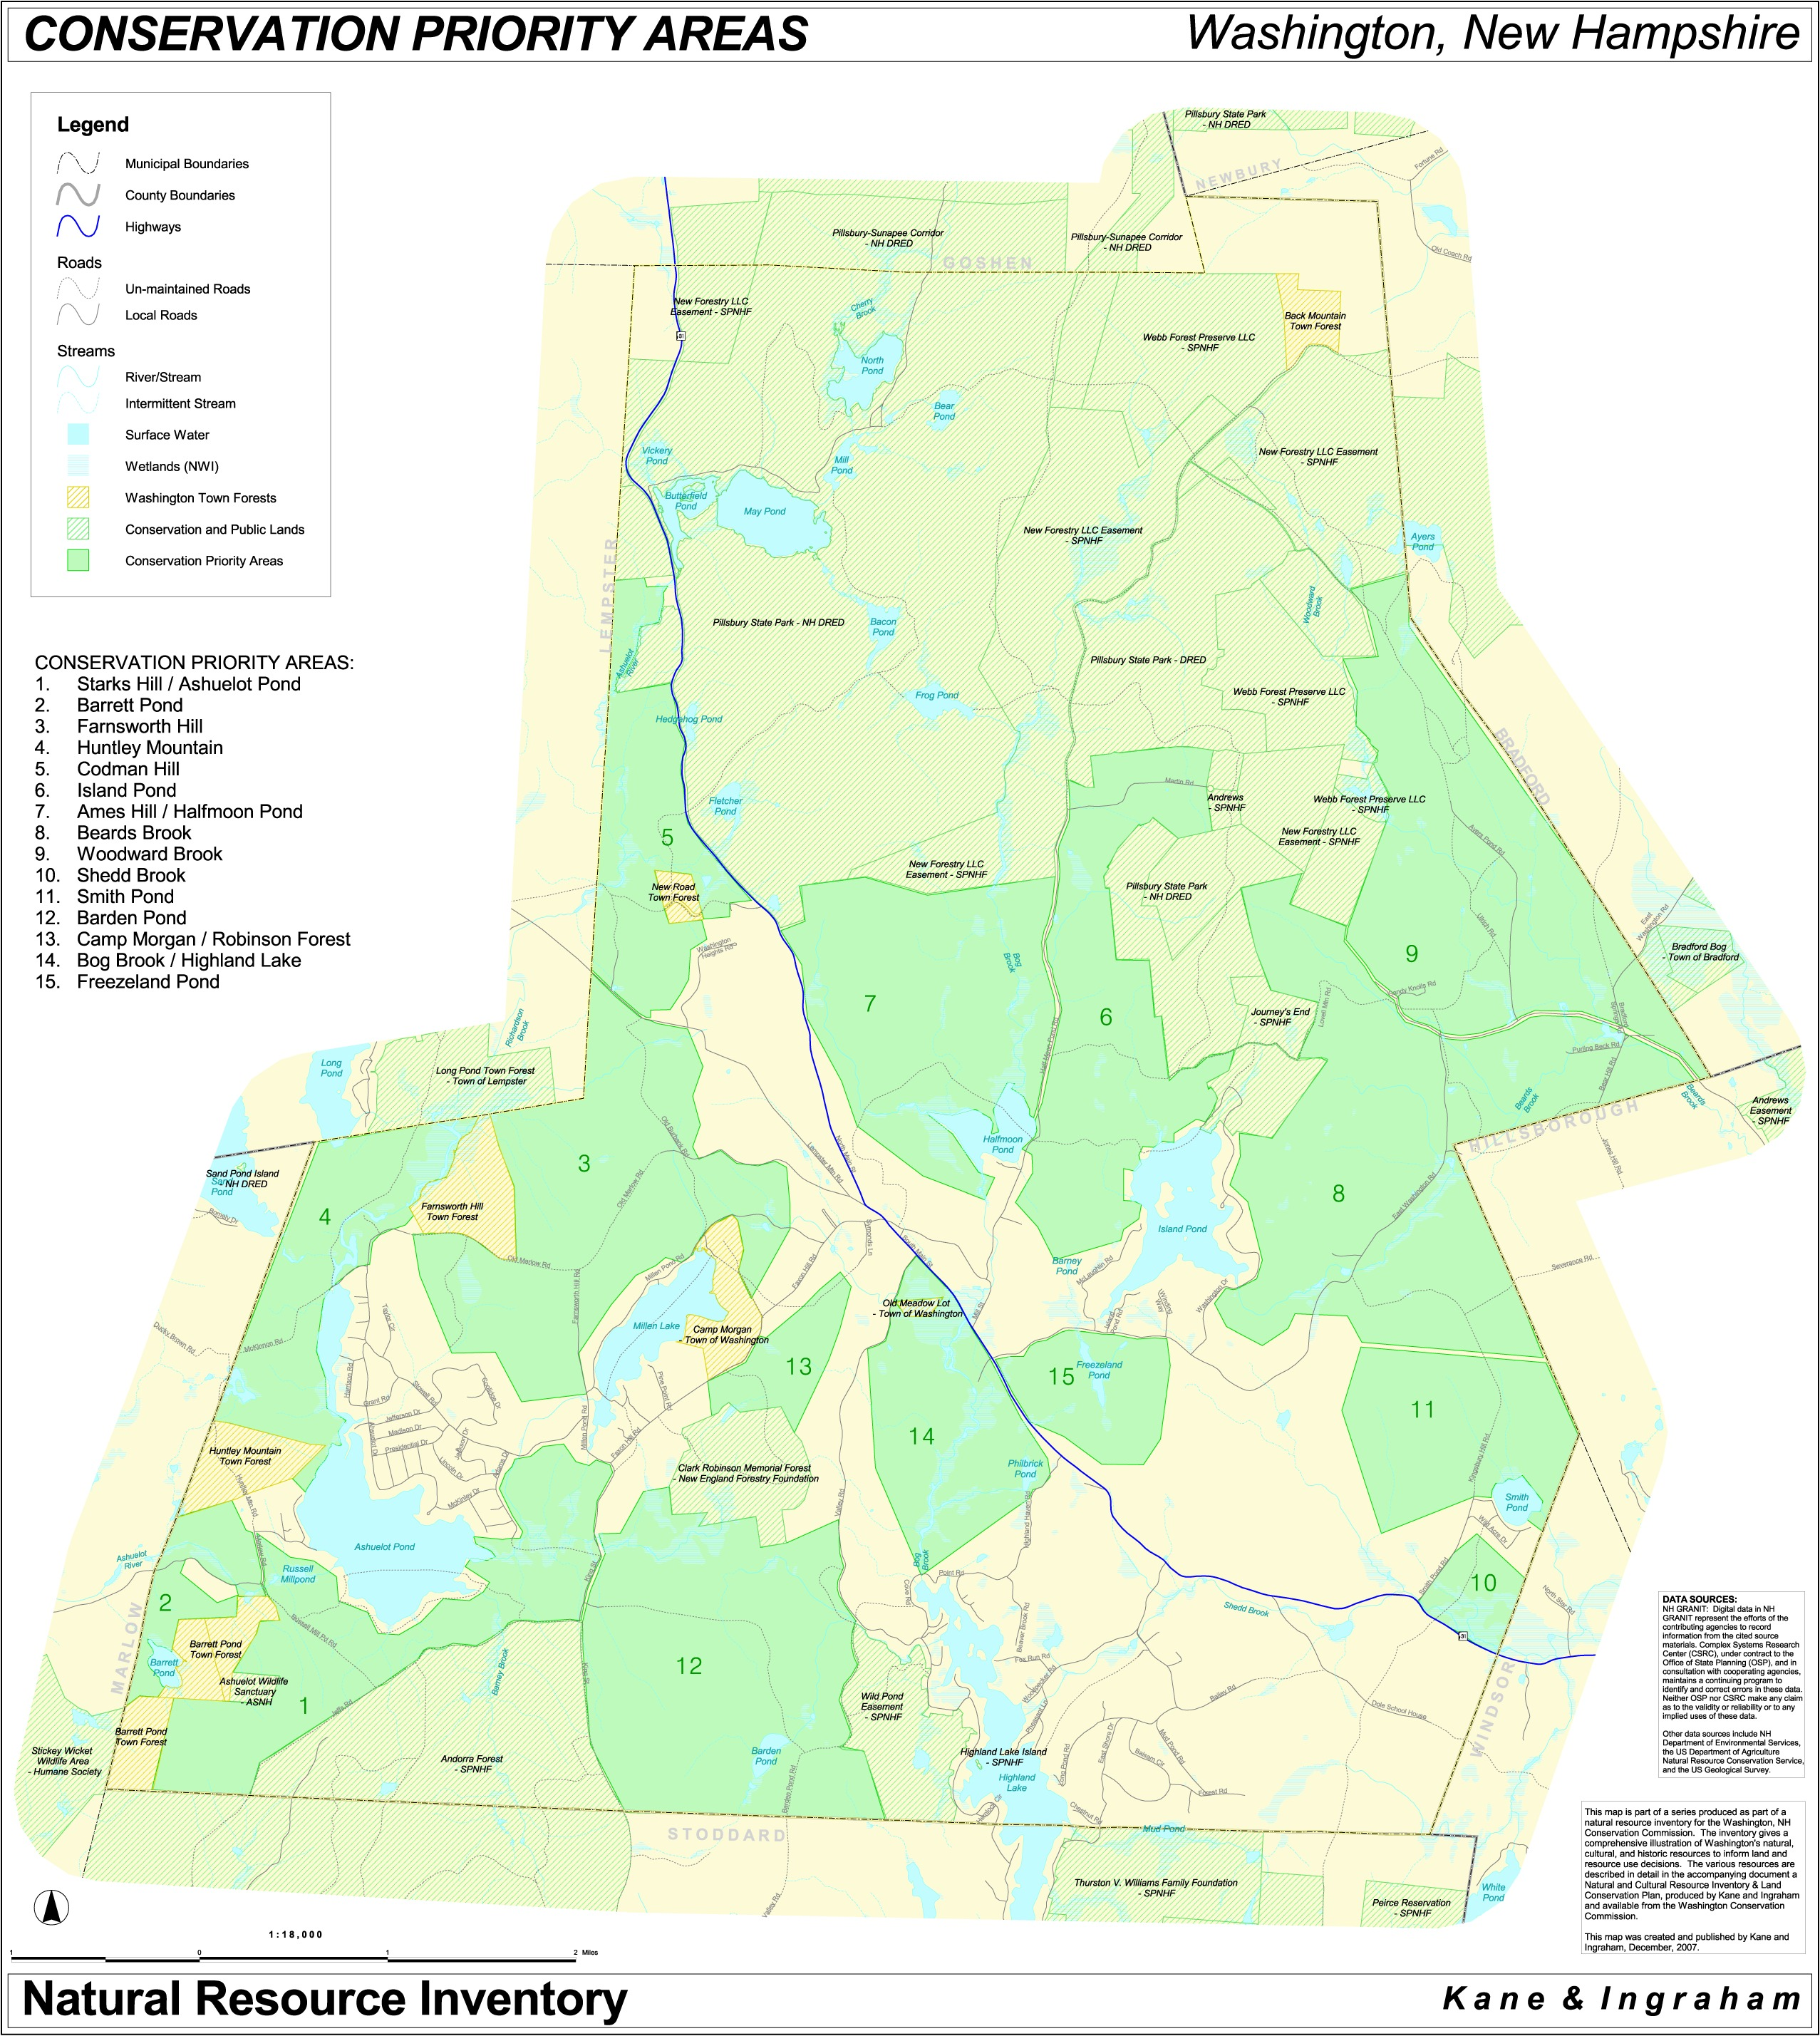

Town-wide Land Conservation Priorities

The areas represented by the Conservation Priority Areas described above include most of the known significant natural resources, and many of the known cultural resources in Washington. In some cases including entire resources in one of these areas was not considered practical, whether because portions were in areas already developed, physical barriers were present, or for a variety of other reasons. In acknowledgement that these resources may have been omitted from the Conservation Priority Areas, and that other lands important for conservation may be identified in the future, a series of non-site-specific land conservation recommendations are presented here.

Wetlands

Wetlands are important for the variety of functions that they serve, including flood water storage, wildlife habitat, surface water quality, scenic enjoyment and groundwater protection and recharge. Areas that contain wetlands, especially those of significant size should be conserved when possible. Prime wetland designation is one way to enhance protection of the most important wetlands in town. Land conservation is the most comprehensive form of protection, but this ideally should also include a natural upland buffer to help maintain the integrity of the wetland in its role in the larger landscape.

Flood Prone Areas

There are several areas in Town that were mapped by FEMA as being prone to flooding. Most, but not all, of these areas were included in the Conservation Priority Areas. Recent historic flood events in 2005 and 2006 in the Washington area and the larger Ashuelot River watershed underscore the real threat to life and property that even small streams can pose in flood prone areas. Land conservation should be a priority in any flood prone area to help prevent personal injury and property damage from localized flood waters.

Aquifers

Washington is not well endowed with high-quality groundwater sources. However, in several parts of Town such High-Yield Aquifers do exist. Considering their local scarcity, aquifers as a resource should be a high priority for protection. The majority of these areas are included in the Conservation Priority Areas. Land conservation is an ideal and permanent method of protecting those aquifer areas that were not included in the Conservation Priority Areas, such as the Shedd Brook and Ashuelot Pond aquifers.

Wildlife Habitat

Most if not all of the significant wildlife habitat in Washington modeled by the state Wildlife Action Plan was included in the Conservation Priority Areas. However, important wildlife habitat occurrences may be discovered outside of these areas which may warrant some method of conservation. Direct land protection efforts (easements or fee purchases) should endeavor to extend beyond the specific occurrence to ensure that well-connected and well-buffered areas are created to enhance the viability of these species. Other approaches such as landowner incentives for habitat-oriented land management may be also useful in helping to connect and protect wildlife habitat.

Riparian Corridors

Washington sits at the upper reaches of several significant major watersheds; most notably the Ashuelot River watershed. Thus, many of the streams are low-order (1st and 2nd); these low-order streams comprise the majority of the stream miles in any given watershed and therefore often have the largest effect on inputs to stream nutrient levels and sediment. The protection of riparian corridors can have significant watershed effects in terms of reducing sediment inputs, increasing in-stream coarse-woody debris (a benefit for aquatic species and nutrient-cycling), and decreased flood severity. Protective efforts can include direct protection through conservation instruments (easement or fee-purchase) or land management practices where natural land cover is maintained within riparian corridors.

Important Views

Especially pleasing views such as the hill behind the Town Hall, and the view to the west from Camp Morgan beach are a special case for conservation, whereby ideally both the viewpoint and the distant view are important. While views are subjective in nature, they are important to the character of the community, and as such are worthy of consideration for protection. Gathering comments and suggestions from Washington residents about their favorite scenic views would start to document what the community as a whole feels are important scenic resources, and thus which are most worthy of protection.

Recreational Trails

An impressive network of hiking, skiing and snowmobile trails crosses the town of Washington. Through-hikers and day hikers on the Monadnock-Sunapee Greenway, and snowmobilers on the trails maintained by the Washington Snowriders utilize these trails heavily. These recreational experiences are impossible to quantify, yet they add substantially to the quality of life that makes Washington such a good place to live and visit. In many cases these trail corridors cross existing public and conservation lands. Many others are included in the Conservation Priority Areas. Most however are used by the permission of generous private landowners, with no permanent guarantee of continued use. Land conservation that is focused on the protection, and even expansion of these trail corridors wherever they exist will have long-term benefits for recreation. Conservation easements can be paired with trail easements in order to permanently protect the land from development, while helping to protect the public’s right to use the trail.

Enhanced Protection of Town Forests

Five Town-owned properties are Designated Town Forests, designated by vote of the Town. The statute allowing for this designation specifically exempts certain Town property, including a Town Forest, from the selectmen’s authority, and places the management of Town Forests in the hands of either a forestry committee or the conservation commission. Although not conservation land in the strict sense, the intent is that town forest land be reserved and managed for its natural resources. Some municipalities in New Hampshire have pursued more comprehensive protection of these public lands by conveying conservation easements on the properties to qualified parties such as land trust. Under this scenario, the land continues to be owned by the Town and used for Town Forest purposes, but a second party is responsible for guaranteeing that the lands will be available for these uses in perpetuity. As time passes, boards change and unforeseen circumstances may arise that could potentially put the continued Town Forest designation and use at risk. The Town may want to explore the feasibility of placing further guarantees as to conservation use on these important public assets.

Pillsbury State Park

A jewel of the State Park system, Pillsbury State Park offers a primitive outdoor recreational setting that is unique for a park in this part of the state. Other parks offer more amenities and developed facilities, but Pillsbury is the special exception that is a source of local pride for residents of Washington and surrounding Towns. The Town of Washington is strongly in favor of keeping the essentially wild character of Pillsbury for future residents of Washington and visitors to enjoy.

Land Protection Options

Conservation or open space land may be owned publicly or privately. These lands typically have no buildings or other complex man-made structures in current service. The lands may remain in their natural state to serve important environmental and/or aesthetic functions, or they may be used for agriculture, forestry and/or outdoor recreation. Either way, they ensure the continued functioning of the natural and recreational resources that are essential to sustaining Washington’s quality of life. Open space lands may also have historic structures, or may in the past have supported traditional uses that are important elements of Washington’s history.

Protection of private lands in the public interest does not necessarily require public access to these lands. Indeed, public access might be incompatible with other open space uses such as wildlife habitat, fragile plant and animal communities, flood control, or water supply, especially on private lands. Also, public access might be incompatible with an individual property owner's right to privacy.

Methods

In the past land was conserved by the fee acquisition (outright purchase) of a property by a Town or governmental agency, sometimes with restrictions in the deed as to the use of the property. Deed restrictions are still a useful option for the conveyance of property; it can serve to assure the donor that the property will only be used for conservation purposes in the future. The acquisition of properties can happen through gift, bargain sale or purchase. If the Town of Washington acquires land in this way it is strongly recommended that, if possible, restrictions be placed on the property in the initial transaction. This can be done by conservation easement (see below), deed restriction, or, if neither of these options are feasible, by a signed statement of intent from the donor (if applicable).

In the last 30 years or so, the conservation easement has emerged as another widely used tool for land conservation. An easement deed can be conveyed at any time, not requiring that a parcel of land change ownership. Easements deeds convey certain rights, typically the right to develop the property for commercial, institutional or residential purposes, to a qualified entity such as a Town or not-for-profit land trust. The grantee (the entity to whom these development rights are transferred) agrees in the deed to guarantee that the restrictions will be upheld in perpetuity. The landowner still owns the land and may use it for a variety of traditional uses, such as forestry, agriculture or recreation, and may sell or otherwise convey the land, with the restrictions remaining in effect. Conservation easements can be granted by gift, bargain sale or sale at full market value.

Donations of property interest by deed restrictions, conservation easements or bargain sales to a qualified entity such as a Town or land trust involve the donation of property value, and as such may be claimed as a charitable deduction for income tax purposes. The value of a deduction is determined by an appraisal that determines the difference between the value of the fair market value of a property and the value of the property after the restrictions are in place.

Any real estate transfer incurs associated expenses. Legal expenses are often necessary and surveys are also often required in order to verify the location and extent of the property. Stewardship donations are commonly obtained to help defray the costs that are anticipated to cover monitoring for compliance with the restrictions, and to mount a legal defense in the unlikely event that there is a violation. Towns often contribute to such expenses in order to meet community goals for land conservation.

Organizations Available for Land Conservation in Washington

There are several organizations or agencies that are qualified to hold interest in conservation land in the Town of Washington. State agencies such as the NH Fish & Game Department and the NH Department of Environmental Services are potential land conservation partners for the Town, however these dollars are often linked to the protection of very specific resources.

Three large private organizations that work on a state-wide basis could potentially partner with the Town on land conservation projects. These are the Society for the Protection of New Hampshire Forests, The New Hampshire Audubon Society, and the New Hampshire Chapter of The Nature Conservancy. These organizations, however, must take into consideration limited staff time, funding realities, and the tenets of their particular mission when considering new conservation projects. There are currently no regional or local land trusts that include Washington in their region of focus.

Towns are qualified to hold interest in land for public conservation purposes, whether in fee or in easement. The Town of Washington has not yet pursued the option of holding conservation easements on private land. In many ways a Town is well suited to conserve land directly, as the conservation would have direct benefits to the residents of the Town, and local funding mechanisms can be created to support such efforts. Should the Town decide to pursue such an effort, consideration should be paid to the long-term stewardship responsibility that they would accept as easement holder. This sometimes requires finances to cover monitoring and enforcement actions. The Town can also hold executory (secondary) interest in an easement that is primarily held by another entity, thus retaining a conservation interest.

Land Conservation Funding Options: Programs and Sources

While not all land conservation project require funding, it is often necessary in order to meet the community’s conservation goals. A variety of options are available to the Town to help fund important conservation projects. Much of the groundwork has been laid for this, with the Natural and Cultural Resource Inventory and this Conservation Plan; both documents identify the most significant resources. This information can be used to strengthen an application for funds in what promises to be an increasingly competitive funding environment. The following programs are potential sources of conservation dollars.

Forest Legacy Program

Owners of forest land can apply to this program, with preference given to larger parcels. A 25% match is required; this can be met by the protection of other forest land in the area. The program is administered in New Hampshire by the Division of Forests and Lands in the Department of Resources and Economic Development, which forwards approved projects to the US Forest Service for review. This program has been a very important funding source for forested lands in the state and in the Town of Washington.

Contact: Susan Francher - sfrancher@dred.state.nh.us
or Bill Carpenter - bcarpenter@dred.state.nh.us
603.271.2214

Farm and Ranch Lands Protection Program (FRPP)

Privately-owned properties that have at least 10 acres of Important Agricultural Soils in active production are eligible for conservation under this program. Funding is in the form of matching funds provided to local governments or other qualified entities toward the purchase of conservation easements. Lands with historical and archeological resources are also eligible for funding under this program.

Contact: Steve Hundley – steven.hundley@nh.usda.gov
603.868.7581 X110
www.nh.nrcs.usda.gov/programs/NH_FRPP_Documents.html

Land and Water Conservation Fund (LWCF)

Parks, open spaces, wildlife habitat and recreational opportunities are available for land conservation funding under this federal program. Funds are allocated to the states which fund up to 50% of the cost of a specific project. Funded projects must be perpetually available for public recreational access, and have facilities that support this recreational use.

Shari Colby – scolby@dred.state.nh.us
603-271-3556
www.nhparks.state.nh.us/ParksPages/CommunityPrograms/ComProgLWCFhom.html

Land and Community Heritage Investment Program (LCHIP)

This State program is subject to variable levels of funding, but is a potential source of land conservation dollars for projects in Washington. Applications are accepted annually, and are considered along with other applications from across the state. Competition is high for this program, and successful projects have numerous substantiated conservation values and a strong case made for their protection. Washington received a $56,000 grant to repair the bell tower of the 1787 Washington Town Hall in Round 4 of this program.

Contact – Cheryl Carlson, office manager at info@lchip.org
603.224.4113
www.lchip.org

Landowner Incentive Program (LIP)

Funding assistance is available for the protection of NH Fish and Game Wildlife Action Plan Priority Habitats or State Listed species or natural communities/systems on private property for the purchase of conservation easements in the Ashuelot River watershed focus area through the LIP program, administered by NH Fish & Game. These include Federal and State listed plants and animals, wildlife and habitats at risk as identified in the NH Wildlife Action Plan, and exemplary natural communities and natural community systems tracked by the Natural Heritage Bureau.

Contact -
Rich Cook
www.wildlife.state.nh.us/Wildlife/Landowner_LIP_program.htm

Center for Land Conservation Assistance

The Society for the Protection of New Hampshire Forests established the Center for Land Conservation Assistance (CLCA) to provide technical assistance to land trusts and Towns relative to land conservation projects, planning, funding and stewardship. In 2002 CLCA published Saving Special Places: Community Funding for Land Conservation written by Brian Hart and Dorothy Tripp Taylor. This publication offers a comprehensive overview of funding options and approaches that New Hampshire municipalities have used to secure funding, as well as case studies and specific examples of successful campaigns.

Contact: Dijit Taylor
dtaylor@forestsociety.org
603.224.9945

Local Funding Sources

The establishment of a local funding source for acquisition of conservation interests including the use of easements, bargain sales, etc. would be desirable and probably necessary in order to achieve the conservation goals set forth above. Through the thoughtful expenditure of public moneys, particularly the Town's Conservation Fund, additional money from other sources can be leveraged. At present, Washington’s Conservation Fund receives 100% of the Land Use Change Tax dollars, a strong commitment for funding land conservation.

Mechanisms for obtaining local public funding are numerous, and each has its strengths and weaknesses that should be carefully weighed before deciding which to pursue. These funding sources include warrant article appropriations to the Conservation Fund, open space bonds, and capital reserve funds for conservation projects just to name a few. The 2002 publication "Saving Special Places: Community Funding for Conservation" has a wealth of information and actual case studies on this topic (see Appendix). This publication is available at www.forestsociety.org/pdf/savingplaces.pdf, or from the Forest Society at 603-224-9945.

VI. Recommendations for Regulatory Actions

Introduction

Important natural resources occur at a variety of scales and locations, and in many cases are not protected by land conservation alone. Residential areas have been established near important resources such as lakes, streams, aquifers and in productive soil areas for many years. Although conservation planning can have an influence on the future uses of important resources areas, it will never be capable of comprehensive protection by itself. Regulations have already been established by local, state and federal governments in order to protect certain natural resources in Washington. There is a role that new regulations may be able to play in protecting specific resources in an efficient and fair manner.

Existing Town Regulations

Land Use Ordinance

The Land Use Ordinance, amended in 2007, addresses permitted uses, lot size and frontage requirements, setbacks, noise, structure height, parking space requirements, fuel tanks, wells, on-site waste disposal and driveways, etc. It also allows for a Cluster Development option that requires an open space set-aside and allows lot sizes down to 1 acre. Non-conforming structures and lots are also addressed.

Subdivision Regulations

The 1995 Subdivision Regulations for Washington, amended in 1997, address the various requirements for applying for a subdivision. This includes application requirements, physical requirements of lots and access, public amenities, site limitations, road standards, open space requirements, tree plantings, utilities and drainage, etc.

Telecommunications Facilities Ordinance

This 2002 ordinance addresses applicability and procedures, application requirements, design and construction standards, removal, and enforcement provisions relating to the siting, construction and use of telecommunications facilities.

Recommended New Town Regulations

Conservation Subdivision Ordinance

Recommendation: Research and implement a new Conservation Subdivision Ordinance as an alternative to standard subdivision. This ordinance should identify important natural resources before permitting, and guide development to other areas of the property. Numerous other municipalities in New Hampshire have already enacted such ordinances, and these could serve as models for such an ordinance in Washington.

Wetlands Zoning Overlay District

Recommendation: Enact a Wetlands Zoning Overly District ordinance to limit the type of use of areas that directly affect water resources. Wetlands are already protected by NH law, but not the adjacent uplands that are inextricably connected to them ecologically and hydrologically. An overlay district that acknowledges the values of wetland borders would help keep these resource systems intact.

Riparian/Wetland Buffer Ordinance

Recommendation: Explore feasibility of a Riparian/Wetland Buffer Ordinance to protect surface waters from impacts resulting from new development. A tiered zone approach keyed to the intensity of a particular proposed use would offer flexibility while protecting the vegetated buffer and limiting inputs from erosion and runoff.

FEMA Floodplain Use Standards

Recommendation: Enroll the Town in the FEMA Flood Protection Program. Ensure that the Town enforces the FEMA Floodplain Use Standards so that property owners who suffer flood losses will be eligible for federal flood insurance benefits. This includes standards for building construction, and the siting of fuel tanks and septic systems in 100 yr. flood zones.

Farm-Friendly Ordinances

Recommendation: Research and consider introducing farm-friendly ordinances to encourage commercial farming. Recently passed legislation allows municipalities to form Agricultural Commissions. The publication Creating an Agricultural Commission in Your Home Town is available at: http://extension.unh.edu/Pubs/AgPubs/AgComm.pdf. Such a commission could study the feasibility of implementing farm-friendly ordinances. The publication Preserving Rural Character through Agriculture: A Resource Kit for Planners may also be of some help.

Class A Trail Designation

Recommendation: Consider the designation of trails in Washington as Class A trails per RSA 231-A. A Class A trail has a full public right-of-way subject to public trail use restrictions. It cannot be used by the public as a vehicular access for any new building or structure, or for the expansion, enlargement, or increased intensity of use of any existing building or structure. It may, however, be used by the owners of land abutting on such trail, or land served exclusively by such trail, to provide access for such non-development uses as agriculture and forestry, or for access to any building or structure existing prior to its designation as a trail. Class A trails are designated for an indefinite period of time, and as such offer a more permanent opportunity for public recreation.

Scenic Road Designation

Recommendation: Explore the designation of official scenic road designation on select portions of roads that offer exceptional views. NH RSA 231:157 allows for the designation by vote of the Town of a local scenic road on any road that is not Class I or II. Designation as a Scenic Road means that repair, maintenance, and reconstruction work to the roadway should not involve the cutting or removal of trees (defined as 15 inches in diameter or more) or the tearing down or destruction of stone walls without prior written consent of the planning board or board responsible for the local Scenic Roads program. This designation does not affect the rights of any abutting landowners on their property, and does not affect the eligibility of the Town to receive construction, maintenance or reconstruction aid. The NH Office of Energy and Planning administers this program. This protection may be appropriate for certain especially scenic local roads in Washington.

Designation of Historic Districts

Recommendation: Explore the designation of Historic Districts to preserve the historic character of clusters and neighborhoods of historic structures and environs by requiring adherence to appropriate standards of building design, renovation and landscaping. Such areas may include the central portions of East Washington Village and Washington Village.

Class VI Road Construction Moratorium

Recommendation: Washington currently maintains a moratorium on construction of new structures accessed from Class VI Town roads. Many undeveloped areas with significant natural resources in Town are protected largely by virtue of being accessible only by un-maintained Class V or VI roads. Allowing new construction on such roads encourages scattered and premature development, and commits the Town to expanded road maintenance responsibilities. The Town should continue this full moratorium accordance with RSA 674:41.

VII. Recommendations for Outreach and Education

Introduction

Education is the basis for sound judgment and informed action. Yet without enough information about a specific topic people may make choices and take actions that are unintentional, but detrimental to the environment. There is a role that the Town can play in providing information to the citizens that will support the conservation goals set forth above. The following list highlights just a few of the possibilities for pursuing the goal of a more informed public.

Importance of Wetlands

Educate the public about the importance of wetlands for flood control and improving water quality. With the memory of the 2005 and 2006 floods still fresh in the minds of the residents, a program that helps make the connection between wetlands and floodwater storage would be effective. This would also help make the case for whatever regulatory measures may be proposed regarding wetlands protection.

No Child Left Inside

Studies are finding that children today spend much less time outdoors in a natural setting than a generation ago. This is true in both rural and urban areas. The result is a generation of children that are afraid to go outside: despite learning much about the natural world on TV and in the classroom, they feel disconnected with the nature outside their own doors. The Town should encourage the introduction of curriculums in the Washington Elementary School that promote a hands-on connection between children and the natural world in Washington. The Camp Morgan Town Forest, with its proximity to the school, could provide the perfect outdoor classroom.

Comprehensive Shoreland Protection Act

The Comprehensive Shoreland Protection Act, recently revised, is intended to protect the shorelines of great ponds and larger streams. As of April 1, 2008 the Ashuelot River in its entirety will be covered by the CSPA. The act alone, however does not guarantee that its guidelines will be followed by the thousands of landowners that it affects. The Town should initiate a public education campaign, aimed particularly at waterfront owners, regarding the Shoreland Protection Act, the importance of septic system maintenance, best management practices for lawn maintenance and the importance of leaving natural vegetation along the shoreline.

VIII. Recommendations for Voluntary Actions

New Hampshire is especially proud of the concept of volunteerism. The state of New Hampshire consistently ranks near the bottom nationally for individual charitable giving, yet ranks near the top for individual volunteerism. Doing the right thing for the right reason, and no pay (or payment) is a tradition here. Programs that rely on interested and active volunteers, and that achieve impressive results are numerous. By engaging interested and committed residents in the cause of conservation on their own land and beyond, optimistic goals can be achieved.

Tree Farms

Designated Tree Farms have helped to promote the wise and informed productive use of private forest lands for many decades. It is in the interest of the Town to encourage the designation of new Tree Farms to promote exemplary forestry practices that conserve forest resources, and help keep these forest lands in sustainable production. Information from the UNH Cooperative Extension which administers the program can be found at: http://extension.unh.edu/Forestry/TreeFarm.htm

Promote Land Uses that Minimize Pollution

The recent findings of the NH Department of Environmental Services Mill Pond Study indicate that there is still work to do regarding the state of awareness that residents have about uses of their land and the potential for pollution. The Town should work with landowners and State & Federal agencies such as the NH Department of Environmental Services and the Natural Resource Conservation Service to explore ways to minimize pollution inputs to local aquifer lands and surface waters.

Lake Volunteer Programs

Lake water quality is of paramount importance not only to the ecological health of a water body, but also to the quality of life of residents who live near them, not to mention their property values. The Town should encourage the established local lake associations (Washington Lake Association, Highland Lake Association, Millen Pond Association, Lake Ashuelot Estates Association, Ashuelot Pond Association) to participate in the Weedwatchers and Lake Host Programs as appropriate to each lake and pond to prevent the introduction of aquatic invasive plant species. The Town should also encourage the lake associations to get involved with the Volunteer Lake Assessment Program to monitor the quality of their lake or pond.

Trails on Town Forests

Town Forest properties hold potential for new recreational opportunities, and connections between existing trails. A group of conservation-minded volunteers could follow the recommendations of the Town Forest Management Plan and lay out and construct new trails on certain Town Forest properties, and move toward the goal of property surveys.

IX. Recommendations for Further Study

Professional Ordinance Review

The Town should sponsor a comprehensive professional review of its Master Plan, ordinances and regulations as they relate to natural and cultural resources. The likely result of this process is that deficiencies in existing regulations will be revealed, and the need for new regulations will be identified. This end result should help avoid confusion and duplication from conflicting regulations, and will help ensure consistency and efficiency of processing applications and inquiries.

Prime wetlands study

A number of New Hampshire communities have undergone the process of formally documenting the most significant wetlands in their Town and designating them as Prime Wetlands according to the requirements of RSA 482-A:15 and Chapter Env-Wt 700 of the NH Department of Environmental Services (NHDES) administrative rules. Wetlands in a Town are evaluated for their relative functions and values by a wetland scientist or other qualified professional. Once adopted by public hearing vote, and accepted as complete by NHDES, such designation affords additional protections to these significant wetlands.

Natural Heritage Bureau Data Request

The Town should formally request NH Natural Heritage Bureau data on rare species and natural communities and ecological systems for the entire Town for conservation planning purposes. Once this data response is received, it can be used according to an agreement with the Bureau that limits how and for how long this information can be used by the Town boards. Such data is not otherwise available, and it is important that the Town be able to take such rare biological resources into consideration while making decisions.

Conduct Specific Field Surveys to Verify WAP Priority Habitat Areas

The Wildlife Action Plan recently released by NH Fish & Game used a modeling approach to predict the presence of priority wildlife habitat across the state. Using this information, field surveys should be conducted in these areas to determine habitat types and conditions, and whether there are any species of conservation concern present.

Conduct Field Surveys to Identify Areas of Ecological Significance

The Town should conduct field-based inventories of the Town on a more comprehensive but targeted fashion to locate and document areas of ecological significance, and to guide protection of these resources. Starting where the current planning documents end, this on-the-ground process will provide more detailed information for conservation planning. A mussel survey of the lower Ashuelot River below Ashuelot Pond to search for the globally rare dwarf wedge mussel, and state-rare brook floater mussels known to occur further downstream, is an example of such a targeted field survey. It is also recommended to conduct further field surveys to ground-truth the presence of the Priority Habitats grasslands, peatlands, floodplain forests and high-quality examples of marsh and shrub wetlands in Washington that are predicted by the Wildlife Action Plan.

GPS & Document Historic Structures and Features

The exact location of many historic and cultural features in Washington is not currently documented. More accurate locations can be obtained by the use of portable Global Positioning System (GPS) units. A group of interested volunteers could use the maps produced in the Natural and Cultural Resource Inventory and other local information to locate these features in the field, and document them and their location. Such information would be useful for planning and outreach purposes.

X. Appendix. Sources

Sources

Ashuelot River Local Advisory Committee. 2001. Ashuelot River Corridor Management Plan. Ashuelot River Local Advisory Committee.

Auger, P., J. McIntyre. Revised by A. J. Lindley Stone. 2001. Natural Resource Inventories; A Guide for New Hampshire Communities and Conservation Groups. UNH Cooperative Extension. Durham, NH.

Chute, L. & G. Dubois. 1999. Management Plan for the Town of Washington Town Forest Lands. Washington, NH.

Clyde, M. E., D. Covell & M. Tarr. 2004. A Landowner’s Guide to Inventorying and Monitoring Wildlife in New Hampshire. U.N.H. Cooperative Extension. Durham, NH.

Comstock, G. & P. Foss. 2006. Total Maximum Daily Load (TMDL) Study for Bacteria in Mill Pond Town Beach, Washington, NH. NH Department of Environmental Services Study NHDES-R-WD-06-32. Concord, NH.

Hardy, D. 1991. Monadnock-Sunapee Greenway Trail Guide. Society for the Protection of New Hampshire Forests. Concord, NH.

Hart, B. & D. T. Taylor. 2002. Saving Special Places: Community Funding for Land Conservation. Center for Land Conservation Assistance. Concord, NH.

Jager, R. & G. Jager. 1977. Portrait of a Hill Town; A History of Washington, N.H. 1876-1976. The Village Press, Inc. Concord, NH.

Jager, R. & G. Jager. 1976. Historical Pillsbury; A Brief History of Cherry Valley, Washington, New Hampshire. The Society for the Protection of New Hampshire Forests. Concord, NH.

Kane, C. 1999. Willow Brook Watershed Natural Resource Inventory and Conservation Plan. Warner Conservation Commission. Warner, NH.

Kanter, J., R. Suomala & E. Snyder. 2001. Identifying and Protecting New Hampshire’s Significant Wildlife Habitat. Non-Game and Endangered Wildlife Program of the N.H. Fish & Game Department. Concord, NH.

NH Fish & Game Department. 2005. New Hampshire Wildlife Action Plan. NH Fish & Game Department. Concord, NH.

New Hampshire Natural Heritage Bureau. 2006. Rare Plants, Rare Animals and Exemplary Natural Communities in New Hampshire Towns. Department of Resources and Economic Development. Concord, NH.

New Hampshire Forest Sustainability Standards Work Team. 1997. Good Forestry for the Granite State: Recommended Voluntary Forest Management Practices for New Hampshire. NH Division of Forests & Lands, DRED; Society for the Protection of New Hampshire Forests. Concord, NH.

Nichols, W.F. & B.D. Kimball. 2002. Inventories of Wetland Natural Communities and Ecological Systems in Southwestern New Hampshire. New Hampshire Natural Heritage Bureau. Concord, NH.

Society for the Protection of New Hampshire Forests. 2007. Quabbin to Cardigan Initiative. Society for the Protection of New Hampshire Forests. Concord, NH.

Society for the Protection of New Hampshire Forests, The Nature Conservancy NH Field Office. 2005. New Hampshire’s Changing Landscape 2005. Society for the Protection of New Hampshire Forests. Concord, NH.

Sperduto, D. D. & W. F. Nichols. 2004. Natural Communities of New Hampshire. New Hampshire Natural Heritage Bureau and The Nature Conservancy. Concord, NH.

Thorne, S. & D. Sundquist. 2001. New Hampshire’s Vanishing Forests: Conversion, Fragmentation and Parcelization of Forests in the Granite State. Society for the Protection of New Hampshire Forests. Concord, NH.

Washington History Committee. Reprinted 1976. History of Washington New Hampshire From 1768 to 1886. R.C. Brayshaw & Co., Inc. Warner, NH.

Washington, Town of. Revised 2002. Washington Land Use Ordinance. Town of Washington. Washington, NH.

Washington, Town of. Revised 2005. Revision of Master Plan. Town of Washington. Washington, NH.

Washington, Town of. Revised 1995. Subdivision Regulations. Town of Washington. Washington, NH.

Zankel, M. 2004. A Land Conservation Plan for the Ashuelot River Watershed. The Nature Conservancy. Concord, NH.

