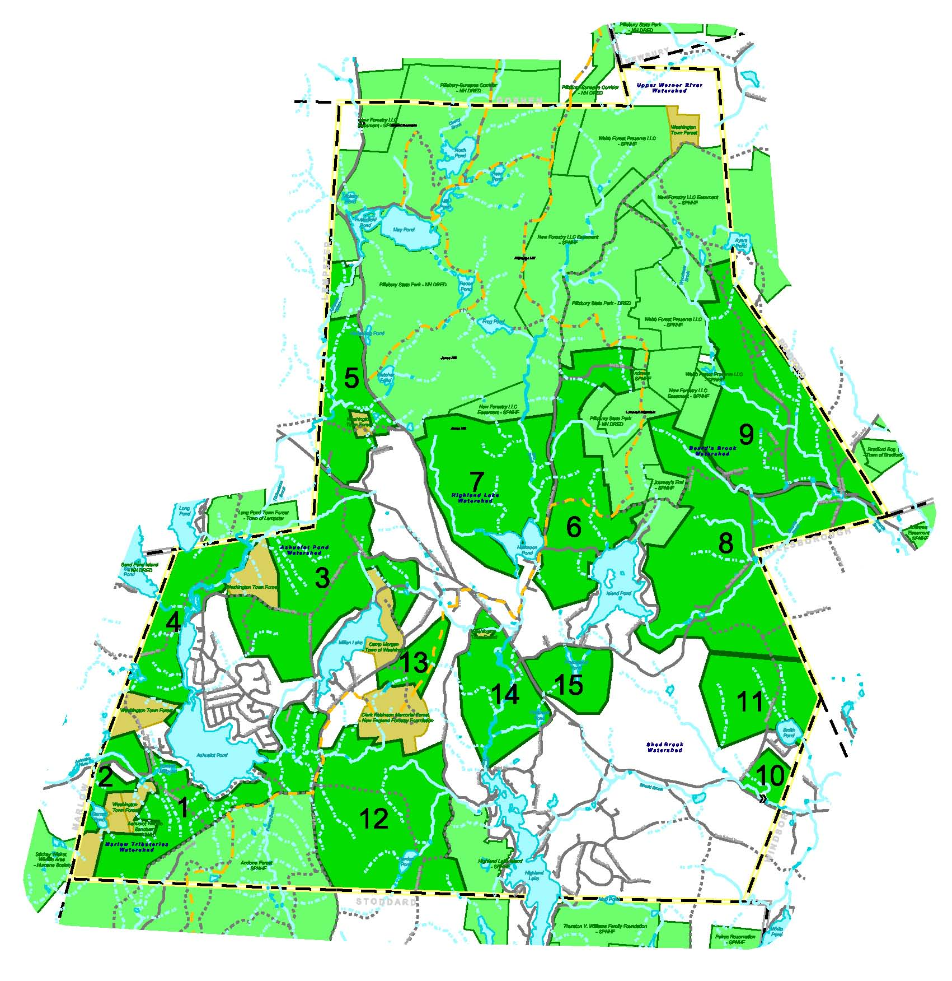

Conservation Priority Areas Key
1. Starks Hill/Ashuelot Pond 2. Barrett Pond 3. Farnsworth Hill 4. Huntley Mountain 5. Codman Hill 6. Island Pond 7. Ames Hill/Halfmoon Pond 8. Beards Brook 9. Woodward Brook 10. Shedd Brook
11. Smith Pond 12. Barden Pond 13. Camp Morgan/Robinson Forest 14.Bog Brook/Highland Lake 15.Freezeland Pond

